# Developer Quick Start into Power BI Embedding

The first chapter provided an overview and introduced the high-level concepts and terms used in Power BI embedding. The goal of this chapter is to get you up and running with Power BI embedding in Visual Studio as quickly as possible. For many developers, there is simply no substitute for the experience of pressing the {F5} key in Visual Studio and seeing how all their theoretical knowledge has been translated into a running, functional web application.

This chapter provides lab exercises with step-by-step instructions to develop your first application which uses Power BI embedding. You will begin by creating a Power BI development environment by signing up for an Office 365 trial tenant. Once you have created a new Office 365 tenant, you will then configure it to allow service principals to call the Power BI Service API which is required when developing for app-owns-data embedding and the third-party embedding model. After that, you will create a new app workspace and populate it with Power BI content including a dataset, a report and a dashboard. Next, you will create a new Azure AD application which makes it possible to call the Power BI Service API with an app-only identity. Once you have prepared your environment and created an Azure AD application, you will create a ASP.NET web application and write all the code required to embed reports, dashboard and the Q&A experience on a custom web page.

## Exercise 1 - Sign Up for an Office 365 E5 Trial

In the first exercise you will create a new Office 365 trial tenant. As you work through the sign up process for this free trial, you will be asked to provide a user name and a password for an Azure AD user account that will be configured as the tenant Global administrator. You will log in with this account when developing and testing applications that use Power BI embedding. However, it's a good practice that you also test your applications with standard user Azure AD accounts that have no administrative permissions. The trial tenant that you are going to create will allow you to create up to 25 user accounts with Office 365 E5 subscriptions. Remember that any user with an Office 365 E5 subscription is automatically assigned a Power BI Pro license as well.

1. Navigate to the Office 365 trial sign up web page.
   1. Launch the Chrome browser.
   2. Copy and paste the following URL into the address bar of the incognito window to navigate to the signup page.

<https://go.microsoft.com/fwlink/p/?LinkID=698279&culture=en-US&country=US>

* 1. You should now see the form you need to fill out to create your new **Office 365 E5** trial.
  2. Enter your email address and click **Next**.

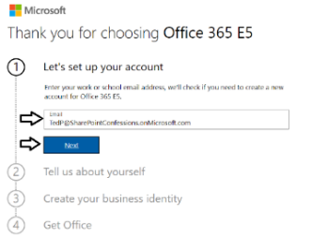

If you enter an email address for an organization account, the form provides the option to sign in using your . Do not click the **Sign in** button because you don't want to sign with an existing organization account. The purpose of this exercise is to create a new organizational account in a new Microsoft 365 tenant.

* 1. Click the Create a new account instead link.

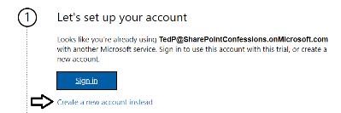

* 1. Enter your First name and Last name.
  2. Enter your mobile phone number as the **Business phone number**.
  3. Provides values for **Company size** and **Country or region** and click **Next**.

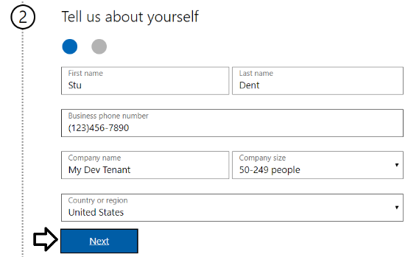

Whatever **Company name** you enter will be used as the name of the Azure AD tenant that will be created during the sign up process.

* 1. When prompted to prove you're not a robot, select the **Text me** option and enter the Phone number of your mobile phone.
  2. Click Send Verification Code.

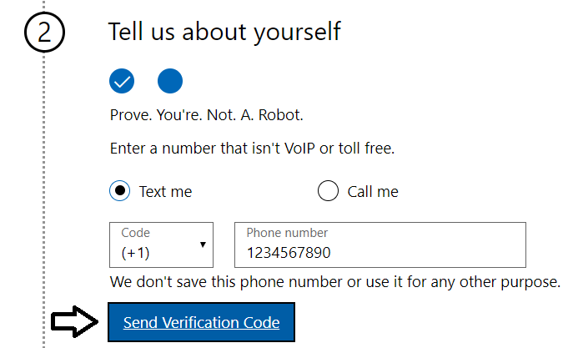

* 1. Retrieve the access code from your mobile device and use it to complete the validation process.

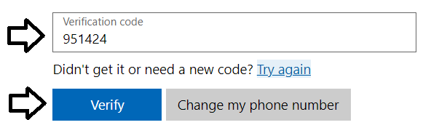

* 1. In the **Create your business identity** step, locate the textbox into which you will enter a domain name.

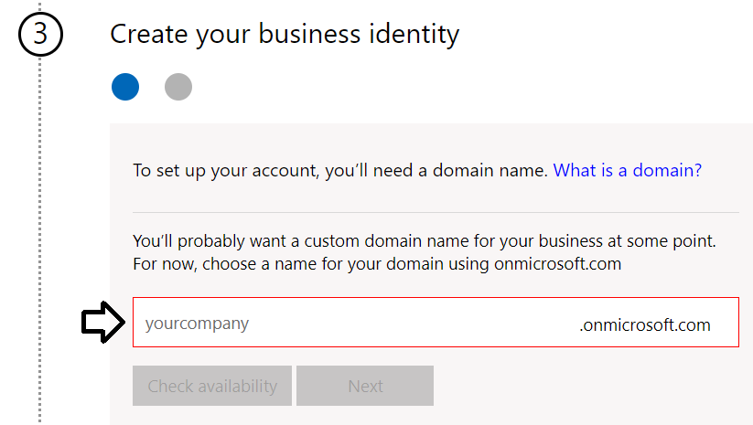

Note that the company name you enter in this textbox will be used to create an Internet domain name for a new Microsoft 365 tenant. For example, if you were to enter a company name of **PBIE2020**, it would result in the creation of a new Office 365 tenant within a domain of **pbie2020.onMicrosoft.com**. The user name you enter will be used to create the first user account which will be given global admin permissions throughout the Azure AD tenant. If you enter a user name of **Student**, then the email address as well as user principal name for this account will be **student@pbie2020.onMicrosoft.com**

* 1. Enter a domain name for your new Microsoft 365 tenant.

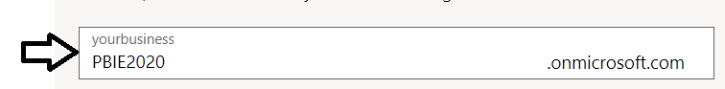

* 1. If the domain name you enter is not available, modify the domain name until you can verify that it is available.
  2. Once you have created a domain name that is available, click **Next**.

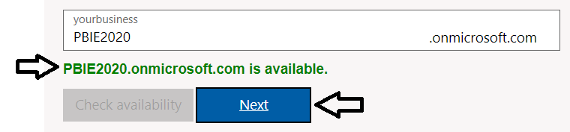

* 1. Enter a **Name** for your user account, a **Password** that you will remember and then click **Sign up**.

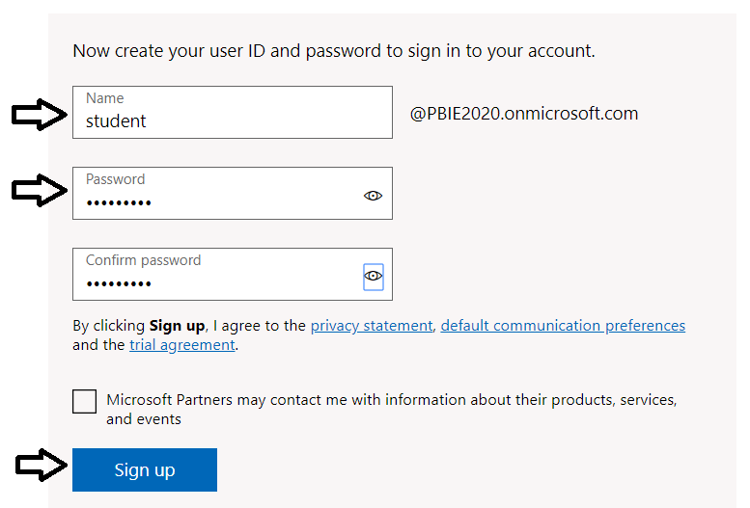

At this point, the Sign up process should begin to provision your new Microsoft 365 tenant and your new organizational account.

* 1. Once the provision process completes, take note of your new **user ID** and click the **Go To Setup** button.

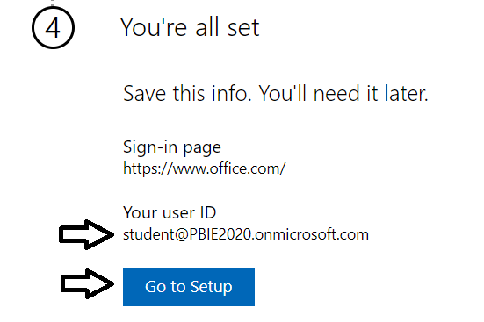

You have just created a new Microsoft 365 tenant with a 30-day trial for 25 Office 365 E5 licenses. Note that some Microsoft cloud services within your new tenant such as the Microsoft 365 admin center, Power BI, PowerApps and Flow can be accessed immediately. Other Office 365 services such as SharePoint Online, OneDrive for Business and your Outlook mailbox will not be ready immediately and can take some time to provision.

* 1. If you see the **Personalize your sign-in and email** setup page, click **Exit** and continue later.

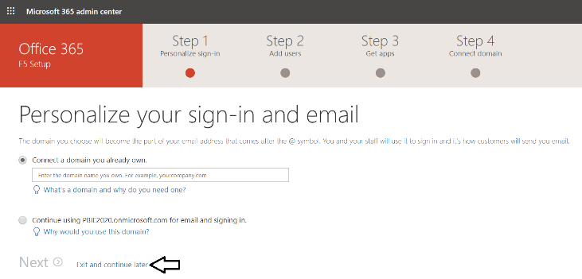

* 1. You should now be located at the home page of the **Microsoft 365 admin center**.

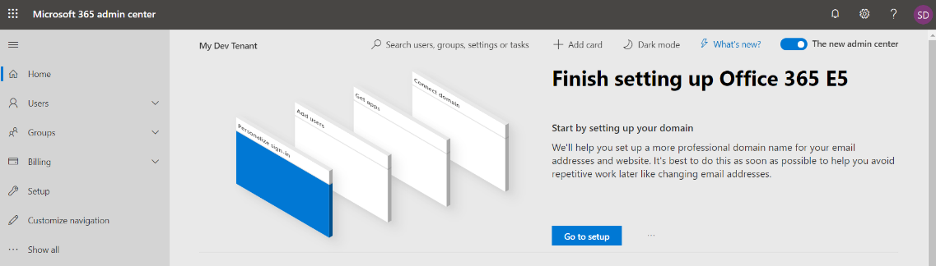

If you don’t see the home page of the **Microsoft 365 admin center**, navigate to <https://admin.microsoft.com/Adminportal>.

1. Inspect the set of active users in the current Azure AD tenant.
   1. Locate the top **Collapse navigation menu** with the hamburger icon just under the Microsoft 365 App Launcher menu.

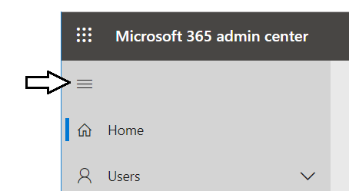

* 1. Toggle the **Collapse navigation menu** button to see how it collapses and expands the left navigation menu.

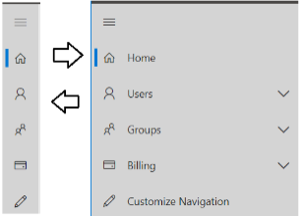

* 1. Navigate to the **Active users** view where you should be able to verify that the user account you are currently logged in as is the only user account that exists in the current tenant.

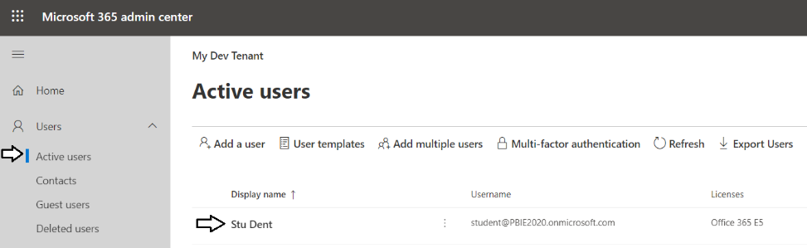

Remember that your account is global tenant administrator. You have permissions to configure any settings throughout the tenant.

1. Create a second Azure AD user account in your new Azure AD tenant.
   1. On the **Active Users** page, click the **Add a user** button to create a new user account

. 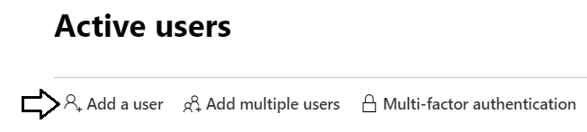

* 1. Fill in the **Set up the basics** form with information for a new user account. When creating this account, you can use any name you would like. These lab instructions will demonstrate this by creating a user account for a person named **James Bond** with a user name and email of **JamesB@PBIE2020.onmicrosoft.com**.

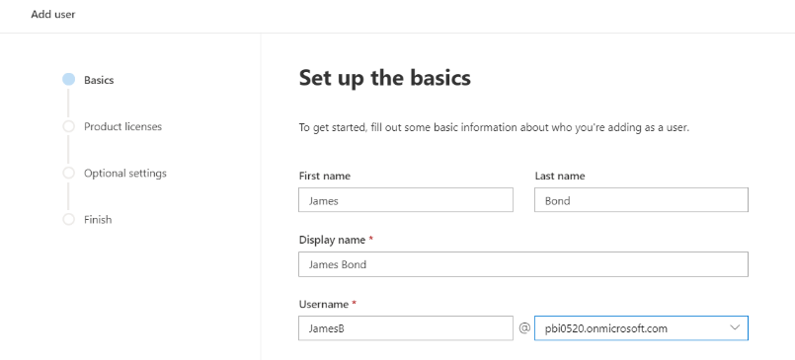

* 1. Move below to the **Password settings** section.
  2. Select the option for Let me create the password.
  3. Enter a password of **pass@word1** into the textbox labeled **Password**.
  4. Uncheck the checkbox for the Require this user change their password when they first sign in option.
  5. Click **Next**.

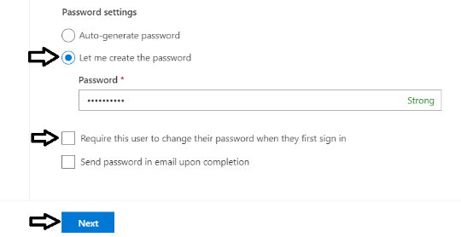

* 1. In the **Product licenses** section, make sure the **Office 365 E5** license is set to **On**.

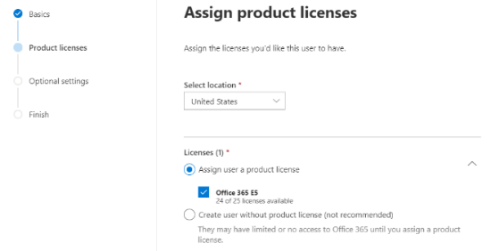

Note that the new account is usually assigned a trial license for **Office 365 E5** plan. However, it’s a good practice to check and make sure the new user has been assigned a license for **Office 365 E5** which includes the **Power BI Pro** license.

* 1. Click the **Next** button.
  2. On the Optional settings view, click Next.

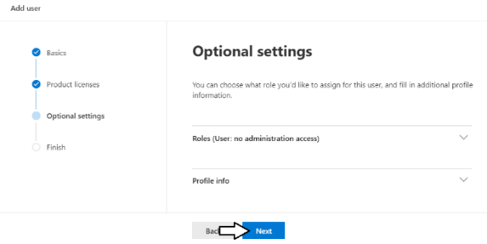

* 1. On the **Finish** view, Click the **Finish adding** button at the bottom to create the new user account.

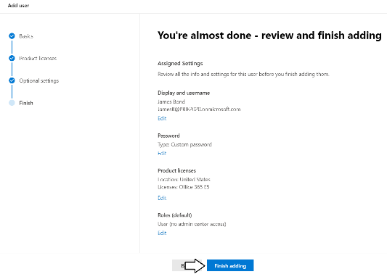

* 1. You should see the **Finish** view with a message indicating that the new user account has been created.

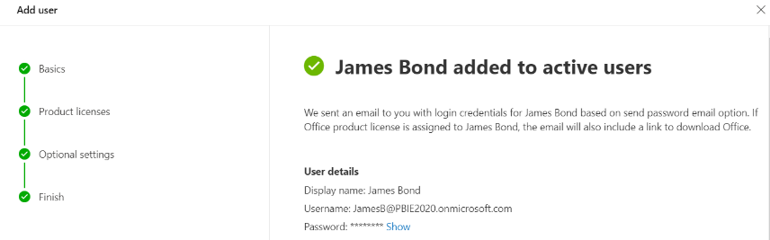

* 1. Click the **Close** button at the bottom of the **Finish** view to close the **Add User** pane on the right.
  2. Verify that the new user account has been created and is displayed along with your primary Office 365 user account.

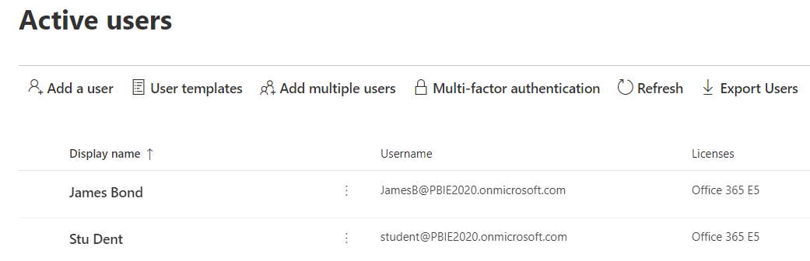

Now you have a secondary user account that does not have any administrative permissions. It's important that you test reports, dashboards and apps with standard user accounts to ensure your application doesn't require users with special permissions.

In the next step you will create a new security group in Azure AD which will be used to configure support to allow service principals to call the Power BI Service API.

1. Create a new Azure AD group for Power BI Service Principals.
   1. Navigate to the **Groups** blade of the Azure AD portal.
   2. Click the **Add a group** button.

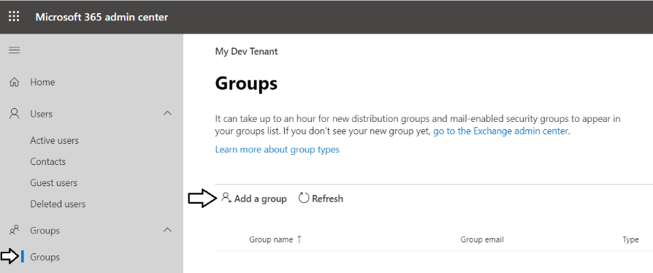

* 1. When prompted to **Choose a group type**, select **Security** and then click **Next**.

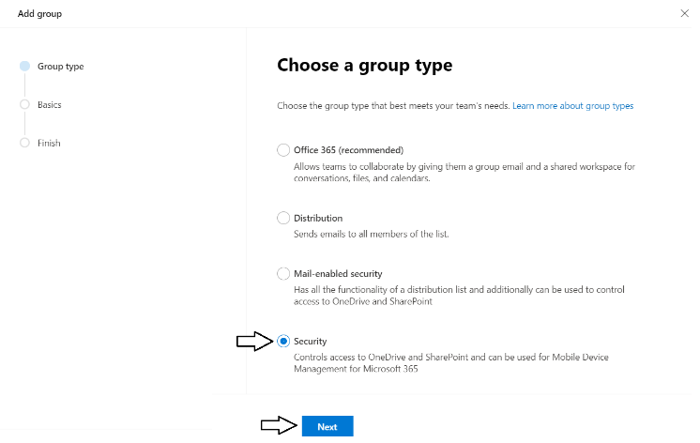

* 1. Enter a **Name** of **Power BI Apps** and click **Next**.

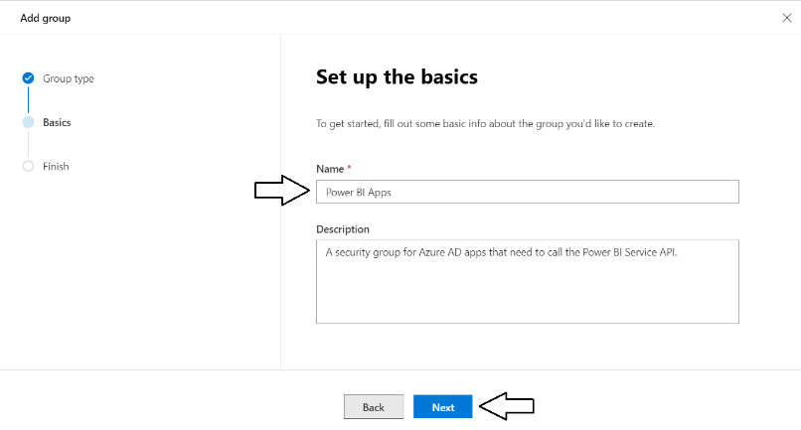

* 1. On the **Review and finish adding group** page, click **Create group**.

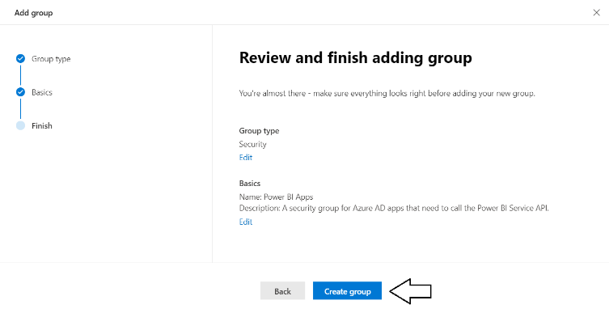

* 1. When you see the **New group created** message, click **Close**.

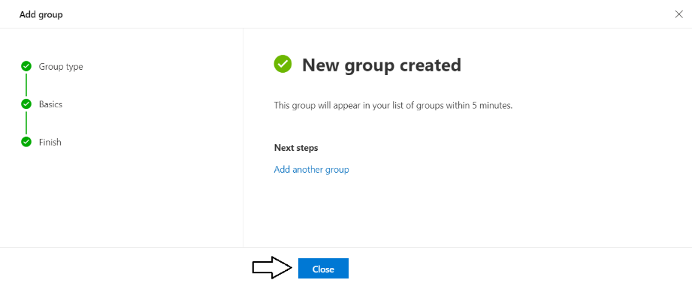

* 1. You should now be able to see the **Power BI Apps** group in the Microsoft 365 admin center **Groups** list.

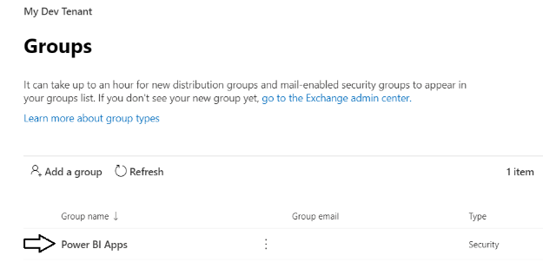

Sometimes it can take two to three minutes before the new group appear in the Microsoft 365 Admin center **Groups** list.

## Exercise 2: Configure Service Principals to Use the Power BI Service API

In this exercise, you configure a Power BI tenant-level setting which will allow service principals to call the Power BI Service API. Configuring this setting is required for an app-owns-data application to call into the Power BI Service API using an app-only identity.

1. Log into the Power BI Service with your new organizational account.
   1. Navigate the Power BI portal at <https://app.powerbi.com> and if prompted, log in using your new organizational account.

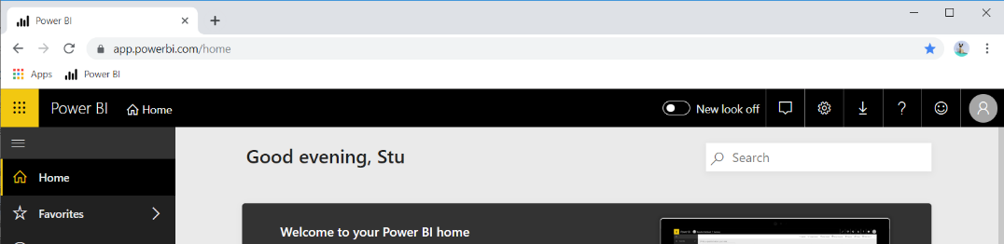

* 1. Locate the **New look** toggle and switch it from **New look off** to **New look on**.



* 1. Click the **Dismiss** button to remove the **Welcome to your Power BI home** panel.

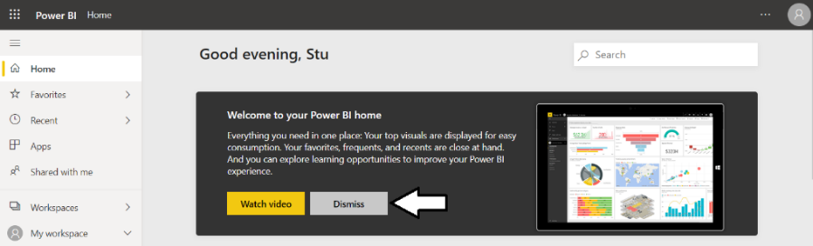

* 1. The home page of the Power BI Service should now match the following screenshot.

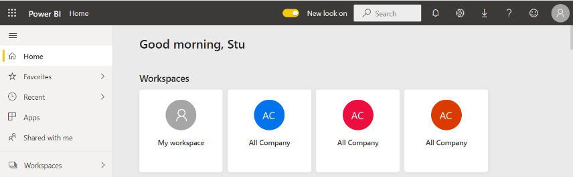

If you haven't worked with the new look of the Power BI Service yet, here's your big chance to get familiar with it.

1. Enable the **Allow service principals to use Power BI APIs** setting and configure it with the **Power BI Apps** security group.
   1. Navigate to the Power BI portal at <https://app.powerbi.com>.
   2. Drop down the **Settings** menu and select the navigation command for the **Admin portal**.

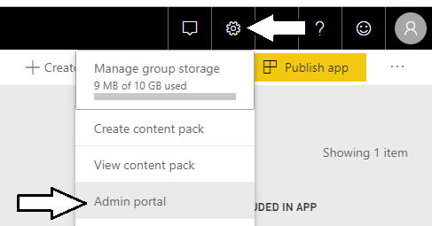

* 1. In the Power BI Admin portal, click the **Tenant settings** link on the left.

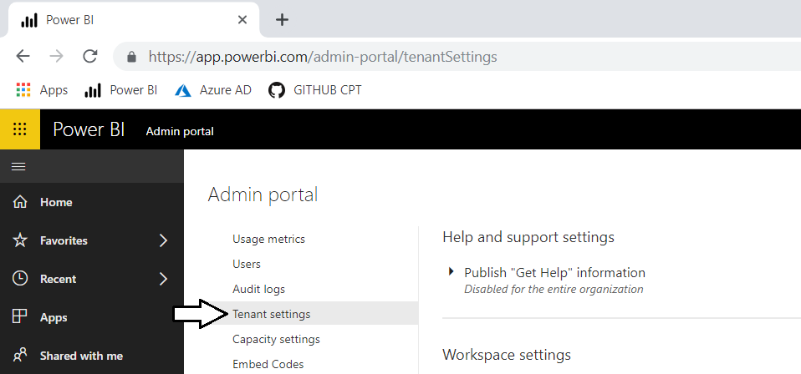

* 1. Move down in the Developer settings section and expand the Allow service principals to use Power BI APIs section.

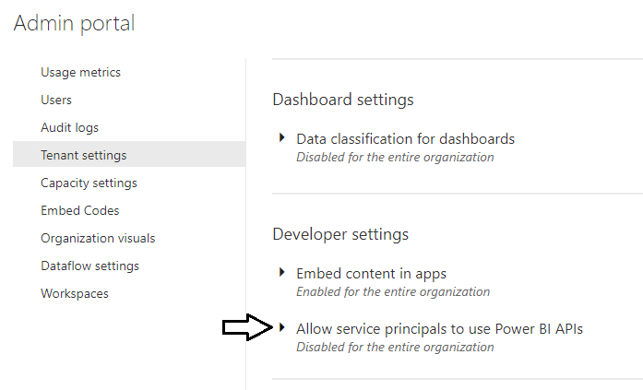

* 1. Note that the Allow service principals to use Power BI APIs setting is initially set to Disabled.

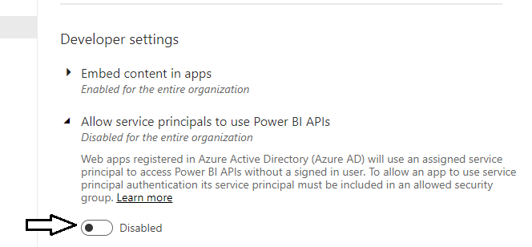

* 1. Change the setting to **Enabled** and place your cursor inside the **Apply to: Specific security groups** textbox.

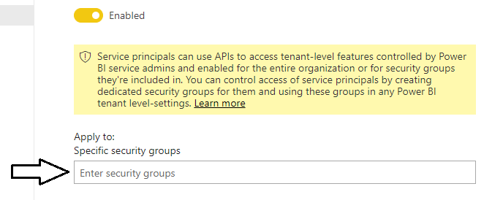

* 1. Type in **Power BI Apps** to resolve the Azure AD group and then click **Apply** to save your configuration changes.

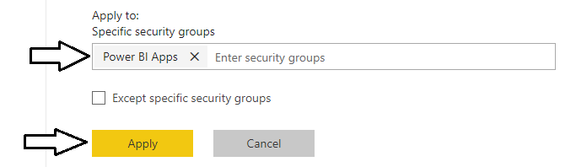

* 1. You will see a notification indicating it may take up to 15 minutes until your tenant recognizes your configuration changes.

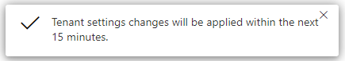

## Exercise 3: Create New App Workspaces for a Custom Solution

In this exercise, you will create a new app workspace so you have a place to publish Power BI content for your custom solutions.

1. Create a new app workspace named **Wingtip Sales**.
   1. Click the **Workspace** flyout menu in the left navigation.

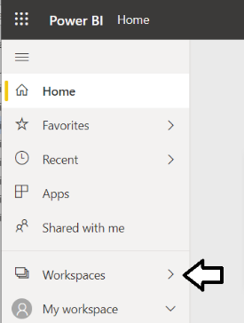

* 1. Click the **Create app workspace** button to display the **Create an app workspace** dialog.

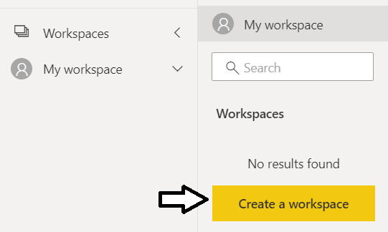

* 1. In the **Create an app workspace** pane, enter a workspace name of **Wingtip Sales**.
  2. Click the **Save** button to create the new app workspace named **Wingtip Sales**.

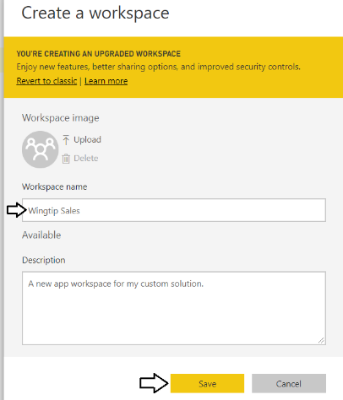

* 1. When you click **Save**, the Power BI service should create the new app workspace and then switch your current Power BI session to be running within the context of this new app workspace.

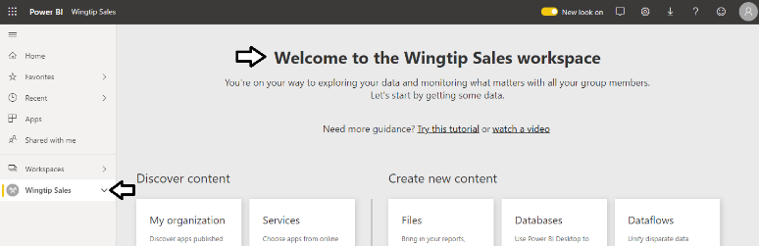

You have now created an app workspace which will provide the foundation for publishing and managing the Power BI datasets, reports and dashboards used by a custom solution.

## Exercise 4: Publish Content to the Wingtip Sales App Workspace

In this exercise, you add content to the **Wingtip Sales** workspace by uploading the PBIX file named **Wingtip Sales Analysis.pbix**.

1. Navigate to the **Wingtip Sales** app workspace that you created in the previous exercise. This workspace should currently display the standard Welcome page because it does not yet contain any datasets, reports or dashboards.

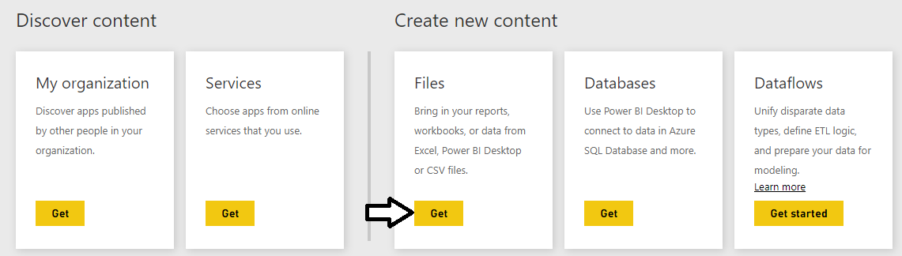

1. Import the **Wingtip Sales Analysis.pbix** project into the **Wingtip Sales** app workspace.
   1. On the Welcome page, click the **Get** button in the **Files** section.
   2. On the **Get Data > Files** page, click the **Local File** button to display the Windows **Open** file dialog.

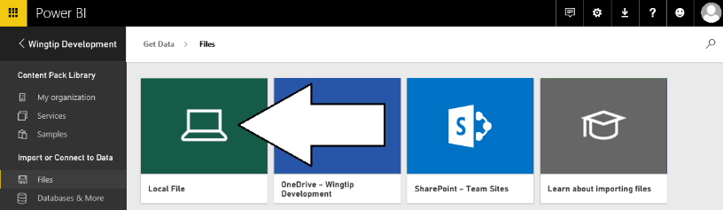

* 1. In the Windows **Open** file dialog, select the project file at **c:\Student\PBIX\Wingtip Sales Analysis.pbix** and click **Open**.

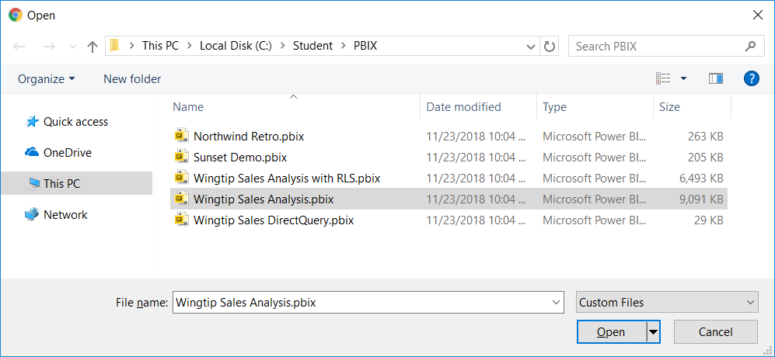

* 1. Wait while the Power BI service uploads the PBIX files and imports its assets into the **Wingtip Sales** app workspace

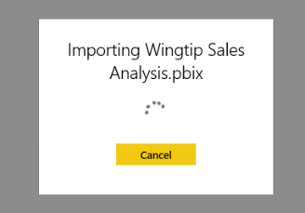

* 1. Check to see if the PBIX upload process has created a new dashboard named **Wingtip Sales Analysis.pbix**.

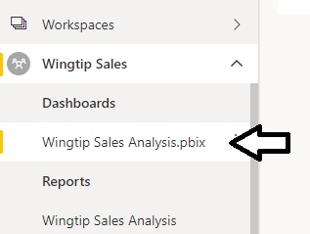

* 1. If it exists, delete the dashboard named **Wingtip Sales Analysis.pbix**.

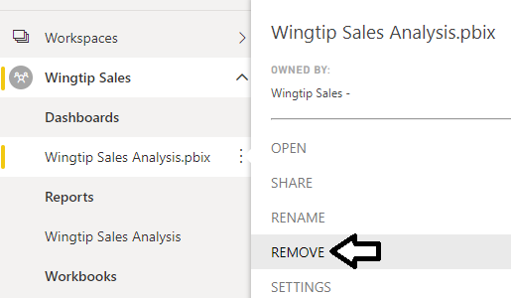

* 1. Now, you should only see a dataset and report in the left nav menu which are both named **Wingtip Sales Analysis**.

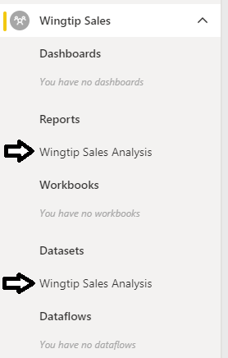

* 1. Click on the report named **Wingtip Sales Analysis** in the **Reports** section.

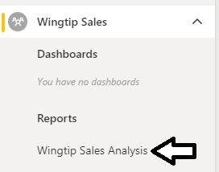

1. Examine the report named **Wingtip Sales Analysis**.
   1. Locate the page tabs on the report.

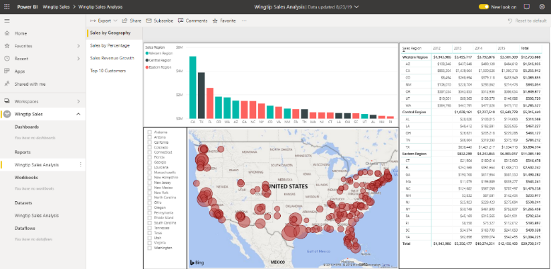

Note that the new look in the Power BI Service brings a significant new change with the layout of the page tabs for a report. While the old look displays page tabs horizontally at the bottom of a report, the new look moves page tabs to the top left in a vertical layout.

* 1. Click on each of the page tabs at the top left of the report to inspect each page of this report,

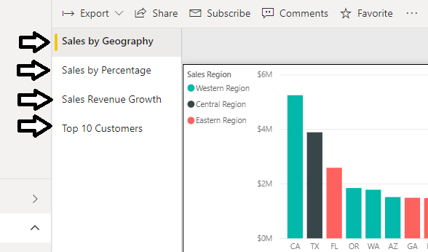

* 1. In the left navigation, click on the dataset named **Wingtip Sales Analysis** in the **Datasets** section. The Power BI service responds by displaying a new report that allows you to begin adding visuals.

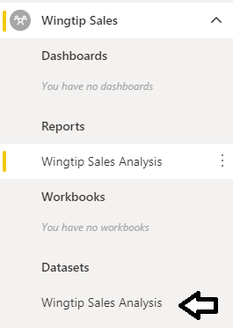

When you navigate to a dataset in the Power BI service, it provides a different experience compared to when in Power BI Desktop. That’s because Power BI Desktop allows you to customize and extend a dataset while the browser-based experience of the Power BI Service only allows you to consume datasets but not to modify them. Given the fact that a dataset is a read-only object, the Power BI Service responds to user’s request to navigate to a dataset by opening a new report and showing the **Fields** list for that dataset.

## Exercise 5: Create and Design the Product Sales Dashboard

In this exercise you will create a new dashboard using the dataset and report you created in the **Wingtip Sale Analysis** project.

1. Create a new dashboard named **Wingtip Sales Analysis**.
   1. Navigate to the **Reports** tab and open the report named **Wingtip Sales Analysis**.
   2. Navigate to the **Sales by Geography** page of the **Wingtip Sales Analysis** report.

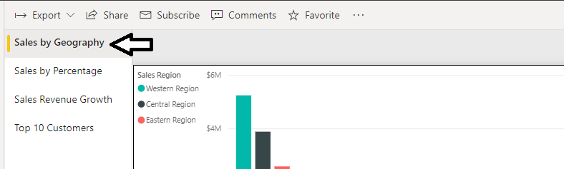

* 1. Hover the mouse over the column chart visual which displays a sales revenue breakdown across sales regions and states.

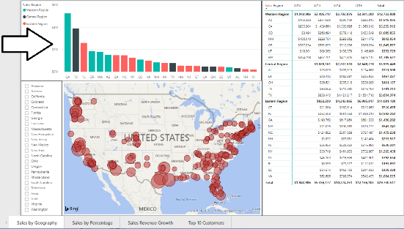

* 1. Locate and click the button with the thumbtack icon to pin this report visual to a new dashboard.

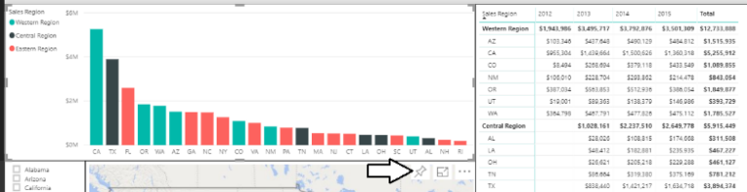

When you click the thumbtack button, you'll be prompted with the **Pin to dashboard** dialog which prompts you to select a dashboard.

* 1. Select **New Dashboard**, give it a name of **Wingtip Sales Analysis** and click the **Pin** button.

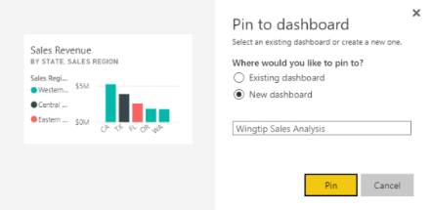

* 1. Click the **Wingtip Sales Analysis** link in the **DASHBOARDS** section of the left navigation to display the new dashboard.

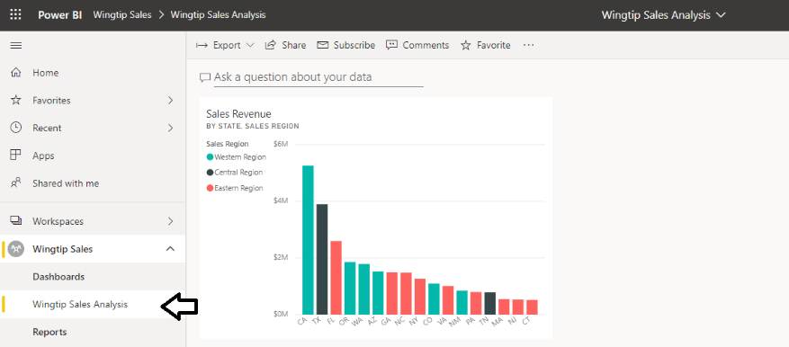

If you haven't previously worked with a Power BI dashboard, take a moment to experiment with resizing and moving the dashboard tile. Unlike a report, the changes you make to a dashboard tile are automatically saved without an explicit save action.

1. Remove the Q&A search box from the **Wingtip Sales Analysis** dashboard.
   1. You can see that the new dashboard is initially displayed with the Q&A search box in the upper left corner.

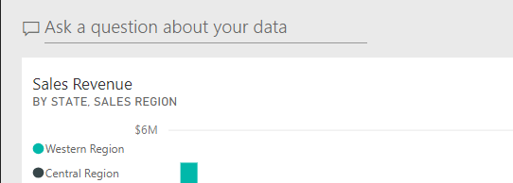

* 1. Click **Dashboards > SETTINGS** in the left navigation to display the **Settings for Wingtip Sales Analysis** pane.

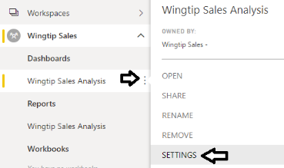

* 1. In the **Settings for Wingtip Sales Analysis** pane, uncheck the **Show the Q&A search box on this dashboard** checkbox.

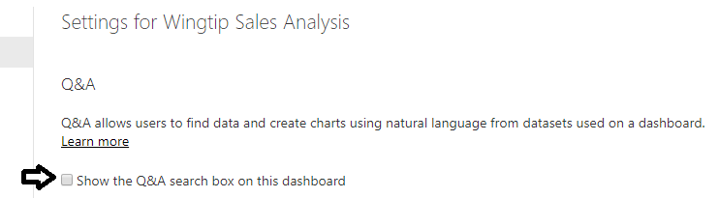

* 1. Click **Apply** below in the **Settings for Wingtip Sales Analysis** pane and confirm the Q&A search box is no longer showing.

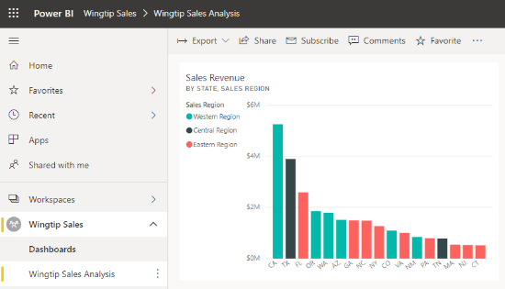

1. Add several more tiles to the dashboard by pinning visuals from the **Wingtip Sales Analysis** report.
   1. Repeat the process you used in step 1 to create the first dashboard tile to add additional tiles to the dashboard.

Choose whatever visuals you’d like from the **Wingtip Sales Analysis** report. However, you should make sure that your dashboard contains several tiles. Be creative and design a dashboard that looks better than the dashboards of the other students around you.

* 1. When you're done, your dashboard should look something like the dashboard shown in following screenshot.

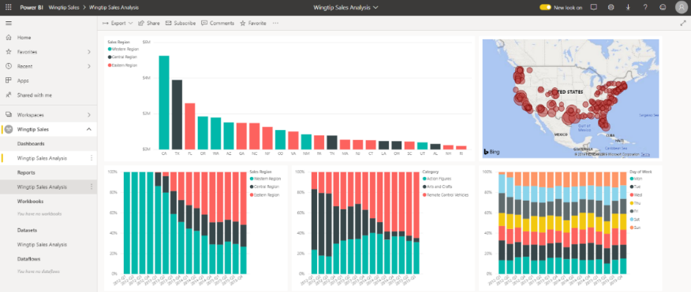

You have now created a dataset, a report and a dashboard. These Power BI resources will serve as your sample content as you begin to develop and test a custom application that implements Power BI embedding techniques.

## Exercise 6: Register a New Azure AD Application in the Azure Portal

In this exercise, you will create a new confidential client application in the Azure portal and you will configure the application’s required permissions to provide the access you need to call into the Power BI Service API.

1. Log into the Azure Portal
   1. In the browser, navigate to the Azure portal at <https://portal.azure.com>.
   2. When you are prompted to log in, provide the credentials to log in with your Office 365 user account name.
   3. Once you have logged into the Azure portal, check the email address in the login menu in the upper right to make sure you are logged in with the correct identity for your new Office 365 user account.

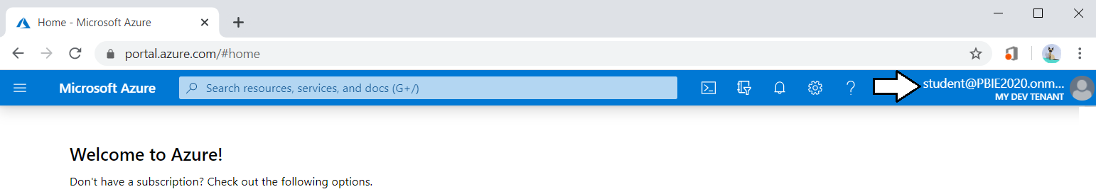

1. Register a new Azure AD application.
   1. Click hamburger icon in the top left corner of the page to drop down the Azure portal navigation menu.
   2. In the left navigation drop down, click the link for **Azure Active Directory**.

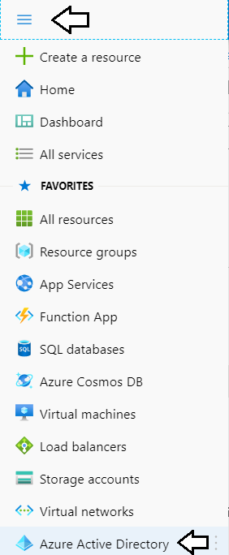

* 1. Once you’ve navigated to **Azure Active Directory** in the Azure portal, click **App registrations** in the left navigation.

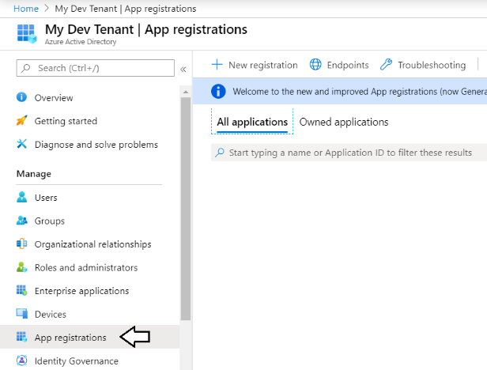

* 1. Click **New registration**.

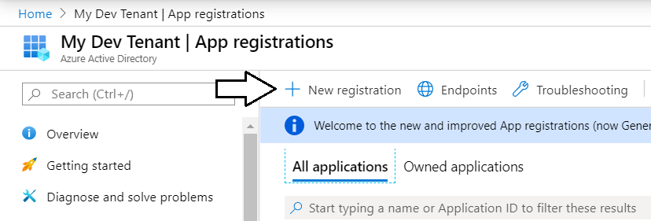

* 1. Enter a **Name** of **App-Owns-Data App**.

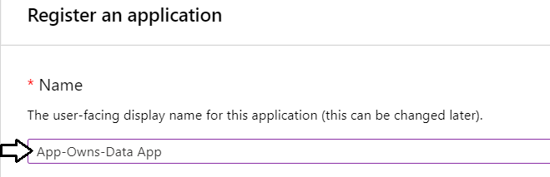

* 1. For the **Supported account types** option, leave the default value of **Accounts in this organizational directory only**.

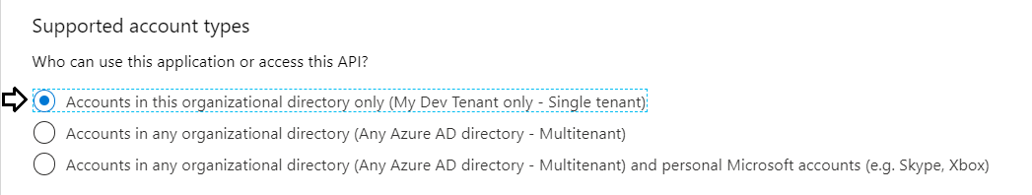

* 1. In the **Redirect URI** section, select **Web** in the left dropdown to create a new confidential client application.
  2. Leave the textbox to the right of the dropdown menu empty as this application will not require a **Redirect URI**.
  3. Click the **Register** button to create the new Azure AD application.

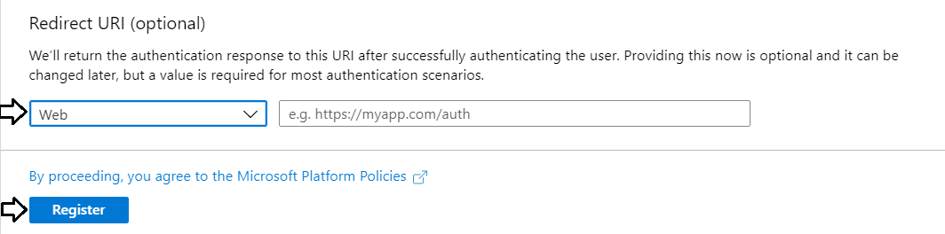

* 1. Once you've created the new application you should see the application summary view as shown in the following screenshot..

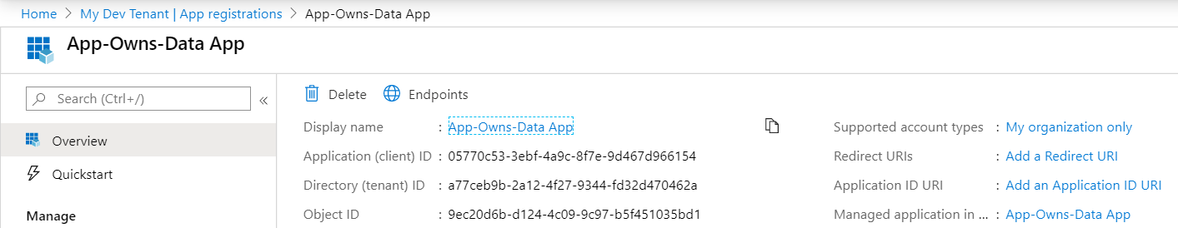

* 1. Copy the **Application ID** to the Windows clipboard.

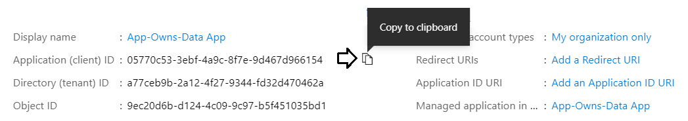

* 1. Launch Notepad and paste the **Application ID** into a new text file.

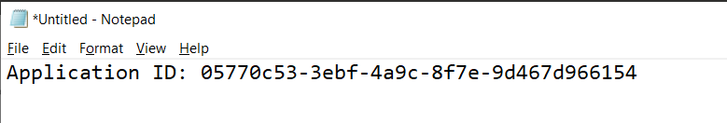

1. Create a new client secret (aka application secret) which will be used for app-only authentication.
   1. Click the **Certificates & secrets** link in the left navigation for **App-Owns-Data App**.

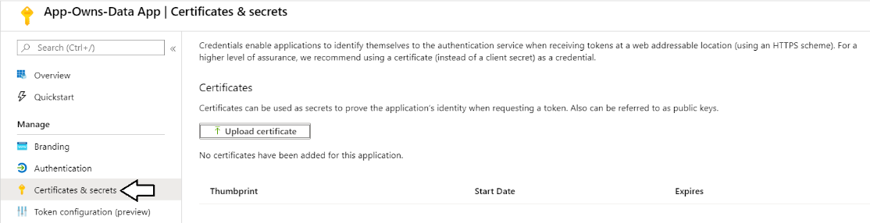

* 1. In the **Client secrets** section, click the **New client secret** button.

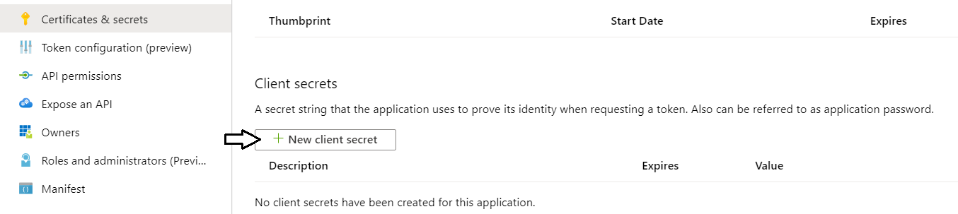

* 1. In the **Add a client secret** pane, enter a **Description** of **App Secret 1** and click the **Add** button.

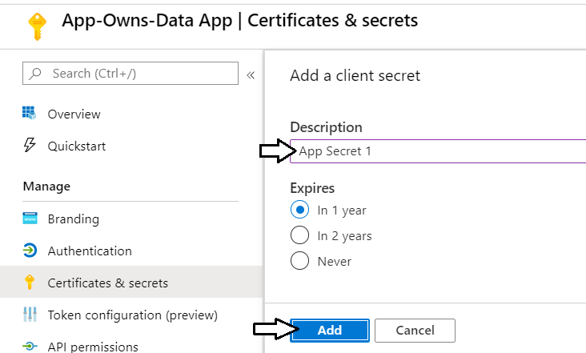

* 1. You should be able to confirm that **App Secret 1** now appears in the **Client secrets** list.

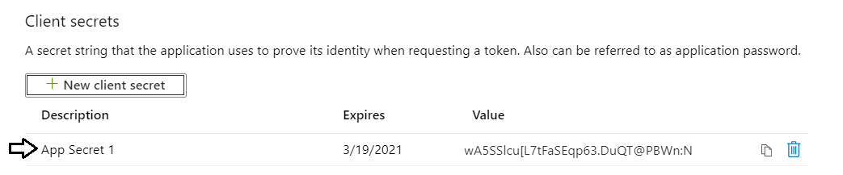

* 1. Click on the **Copy to clipboard** button to copy the new client secret to the Windows clipboard.

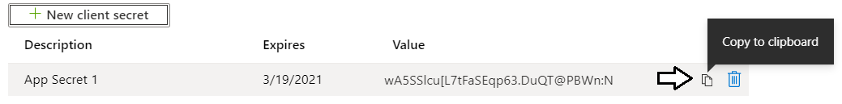

* 1. Paste the client ID into the new document in Notepad and name it Application ID.
  2. Add the Tenant Name to the Notepad document as shown in the following screenshot.

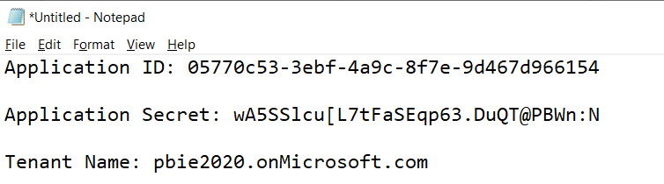

1. Add the Azure AD application named **App-Owns-Data App** to the **Power BI Apps** security group.
   1. Use the drop down navigation menu in the Azure portal to navigate to the **Azure Active Directory** root page.



* 1. Select the **Groups** link in the left navigation of the Azure Active Directory section of the Azure portal.

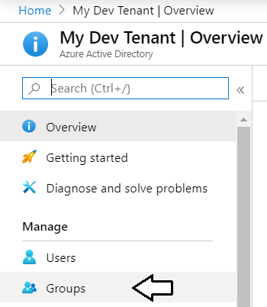

You should be able to see the security group you created earlier named **Power BI Apps**.

* 1. Click on the security group named **Power BI Apps** to drill into its summary page.

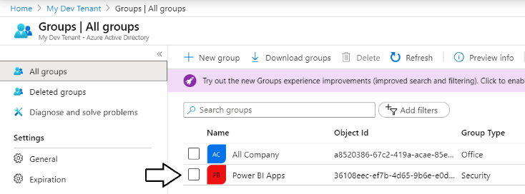

* 1. Click on the **Members** link in the left navigation.
  2. Click on the **Add member** button.

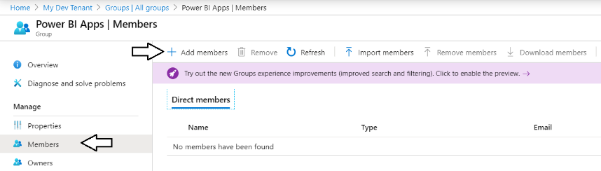

* 1. Type the word “App” into the search box to find the **App-Owns-Data App** service principal.

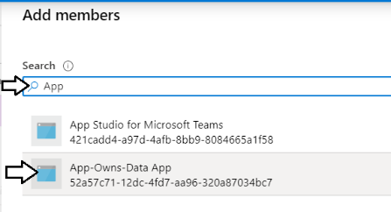

* 1. Select the **App-Owns-Data App** service principal in the **Selected Items** list and click **Select**.

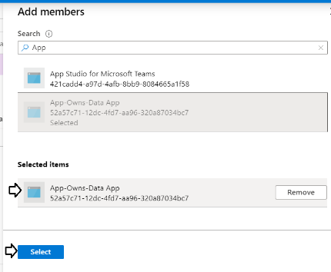

* 1. You should be able to confirm that the **App-Owns-Data App** service principal is now a member of the **Power BI Apps** group.

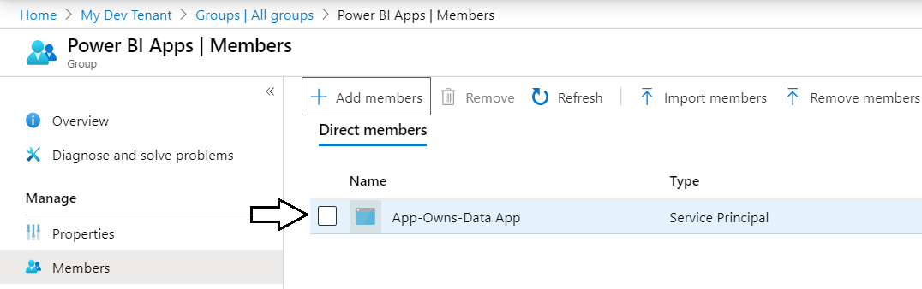

1. Add the service principal for App-Owns-Data App as an admin for the Wingtip Sales app workspace.
   1. Navigate to the Power BI portal.
   2. Expand the **Workspaces** flyout menu.
   3. Click the **Wingtip Sales** workspace context menu (**…**) and select **Workspace access**.

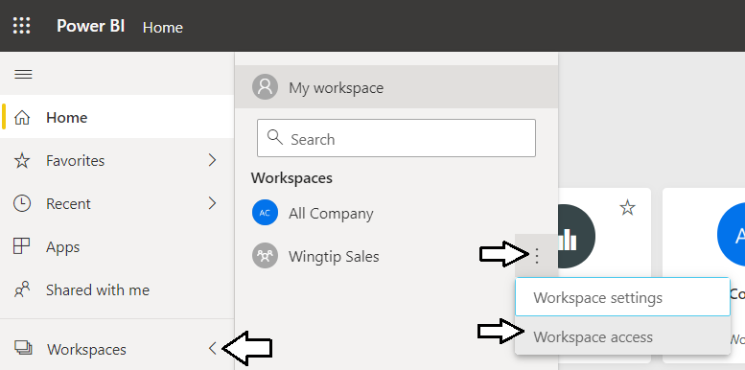

* 1. On the right of the page, you should see the **Access** pane for the **Wingtip Sales** workspace.
  2. Place the cursor into the *Enter email address* textbox and type **App-Owns-Data App**.

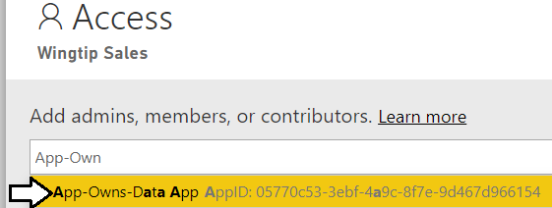

* 1. Change the member type from **Member** to **Admin**.
  2. Click to **Add** button.

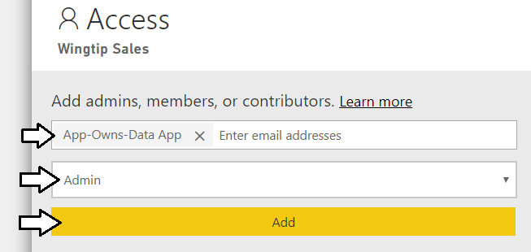

* 1. Verify that **App-Owns-Data App** has been added as a workspace member with **Admin** permissions.

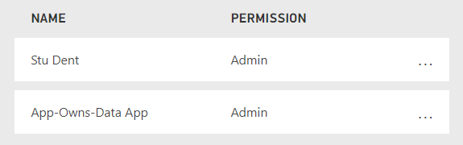

As the final part of this exercise, you will gather the configuration data you will need for your Power BI embedding application.

1. Retrieve the GUID-based IDs for the **Wingtip Sales** app workspace and the embeddable resources inside.
   1. Navigate to the **Wingtip Sales** app workspace in the Power BI portal.
   2. Locate and copy the app workspace ID from the URL by copying the GUID that comes after **/groups/**.

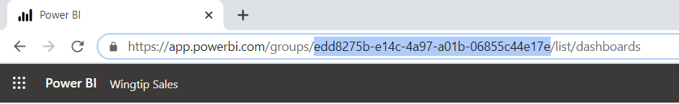

* 1. Copy the app workspace ID into the text file Notepad.
  2. Navigate to the **Wingtip Sales Analysis** dataset inside the **Wingtip Sales** app workspace to create a new report.
  3. Locate and copy the dataset ID from the URL by copying the GUID that comes after **/datasets/**.

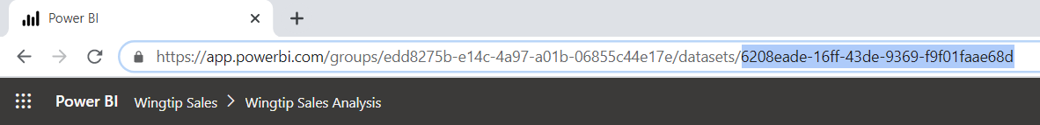

* 1. Copy the dataset ID into the text file Notepad.
  2. Navigate back to the **Wingtip Sales Analysis** report inside the **Wingtip Sales** app workspace.
  3. Locate and copy the report ID from the URL by copying the GUID that comes after **/reports/**.

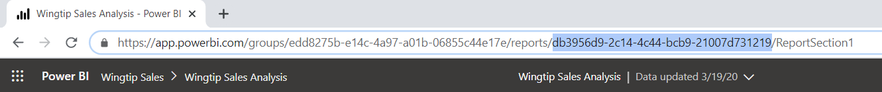

* 1. Copy the report ID into the text file Notepad.
  2. Navigate to the **Wingtip Sales Analysis** dashboard.
  3. Locate and copy the dashboard ID from the URL by copying the GUID that comes after **/dashboards/**.

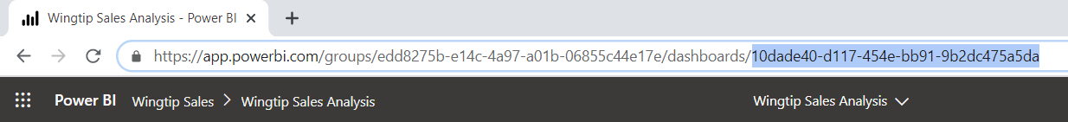

* 1. Copy the dashboard ID into the text file Notepad.
  2. You should have now updated the text file Notepad with all the configuration data you need.

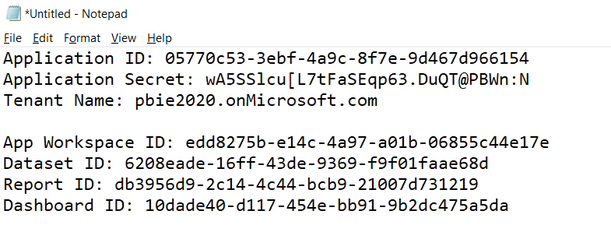

* 1. Save your changes to **AppOwnsDataApp.txt**.
  2. Leave **AppOwnsDataApp.txt** open as you will need it when developing a new application in the next exercise.

## Exercise 7: Create a new MVC Application using Visual Studio 2019

In this exercise you will create a new Web Application project using Visual Studio 2019 and the ASP.NET MVC framework.

1. Launch **Visual Studio 2019**.
2. Create a new ASP.NET MVC project in Visual Studio 2019.
   1. In Visual Studio select **File > New > Project**.

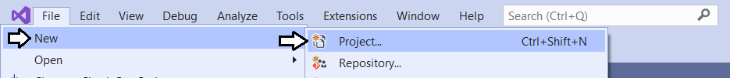

* 1. In the **New Project** dialog:

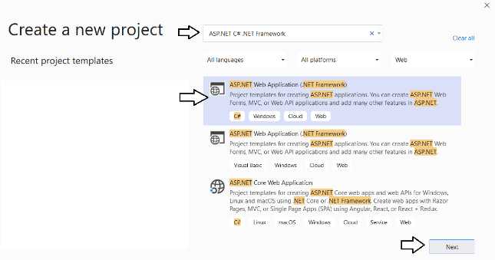

* + 1. Select **Installed > Templates > Visual C# > Web**.
    2. Select the **ASP.NET Web Application** project template.
    3. Name the new project **AppOwnsDataApp**.
    4. Add the new project into the folder at **C:\Student\Modules\05_PowerBiEmbedding\Lab**.
    5. Click **OK** to display the **New ASP.Net Web Application** wizard.

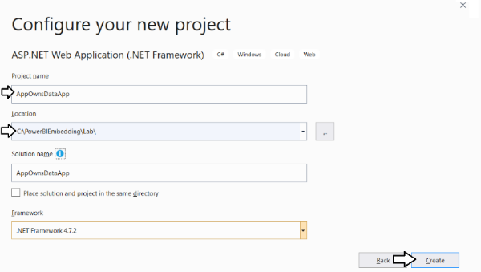

* 1. In the **New ASP.Net Web Application** dialog, select the **Empty** template.
  2. In the section with the caption **Add folders and core references**, make sure the **MVC** checkbox is checked.
  3. Click the **Create** button to create the new project.

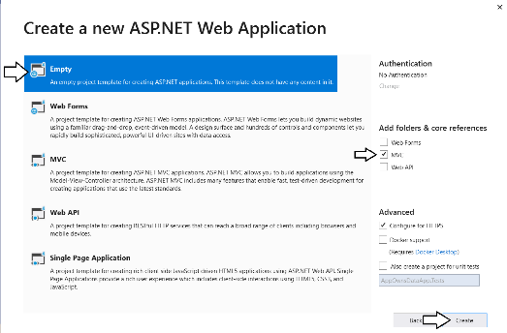

* 1. When Visual Studio finishes creating the project, it displays an information page. Close this page by clicking the **x** in the tab.

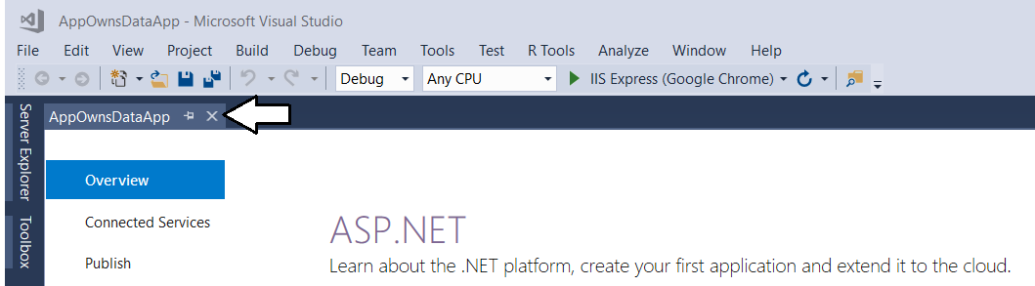

* 1. Take a minute to familiarize yourself with the structure of the **AppOwnsDataApp** project in the **Solution Explorer**.

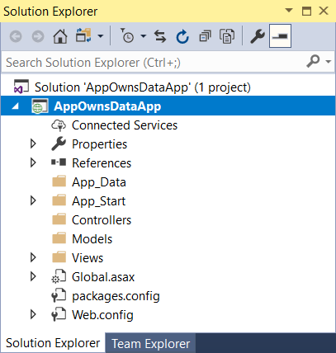

At this point, you have created a new ASP.NET MVC project based on the **Empty** project template. You will need to add an MVC controller and several MVC views before your application provides any type of user interface experience. Before adding a controller or writing any code, you will first update the project’s NuGet packages included with your new project. You will also prepare for Power BI embedding by adding the NuGet package for the Azure Active Directory Authentication library (ADAL) and the NuGet packages for the Power BI .NET SDK and the Power BI JavaScript API.

1. Configure the **AppOwnsDataApp** project with the required set of NuGet packages
   1. From the Visual Studio menu, select the command **Tools > NuGet Package Manager > Package Manager Console**.

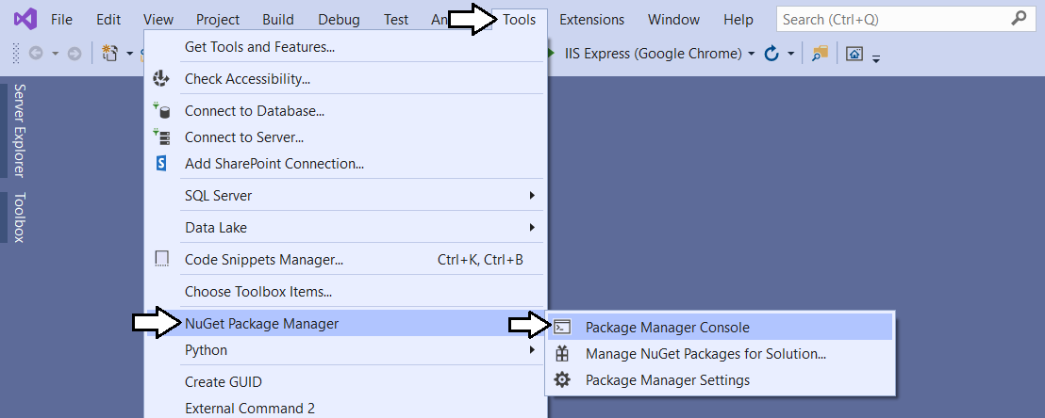

* 1. You should now see the **Package Manage Console** with a **PM>** command prompt as shown in the following screenshot

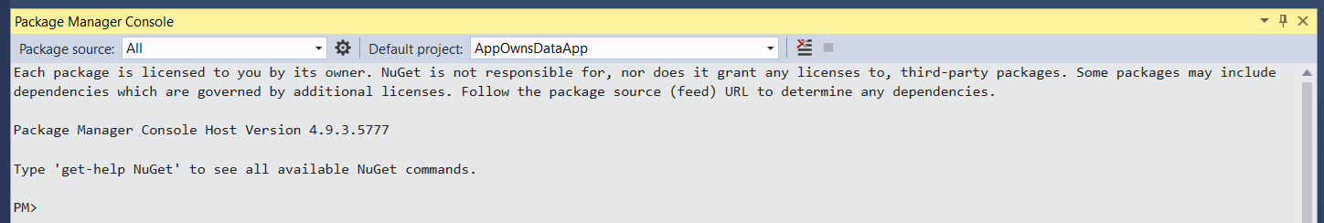

* 1. Type in and execute the following command to install the NuGet package for **jQuery**.

Install-Package jquery

* 1. Type in and execute the following command to install the NuGet package for **bootstrap**.

Install-Package bootstrap

* 1. Type in and execute the following command to install the NuGet package for the **Microsoft Authentication library (MSAL)**.

Install-Package Microsoft.Identity.Client

* 1. Type in and execute the following command to install the NuGet package for the **Power BI .NET SDK**.

Install-Package Microsoft.PowerBI.Api

* 1. Type in and execute the following command to install the NuGet package for the **Power BI JavaScript API**.

Install-Package Microsoft.PowerBI.JavaScript

* 1. Type in and execute the following command to update the NuGet package for the **Newtonsoft.Json**.

Update-Package Newtonsoft.Json

* 1. Type in and execute the following command to update the NuGet package for the **Microsoft.Rest.ClientRuntime**.

Update-Package Microsoft.Rest.ClientRuntime

* 1. Type in and execute the following command to update the NuGet package for the **popper.js**.

Update-Package popper.js

Now you have installed all the required NuGet packages for Power BI embedding.

1. Add the **HomeController** class.
   1. In Solution Explorer of the **AppOwnsDataApp** project, right-click on the **Controllers** folder.

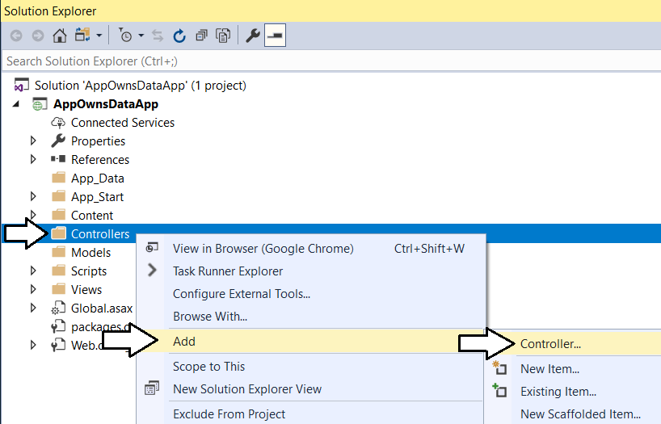

* 1. In the **Add Scaffold** dialog, select the first option **MVC 5 Controller – Empty** and then click **Add**.

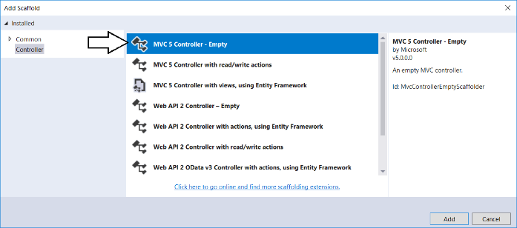

* 1. In the **Add Controller** dialog, enter a **Controller name** of **HomeController** and then click **Add**.

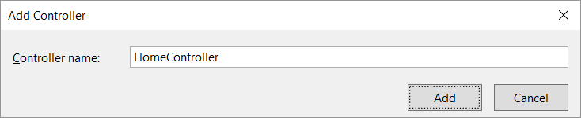

* 1. You should now see a new source file in the **Controllers** folder named **HomeController.cs**.

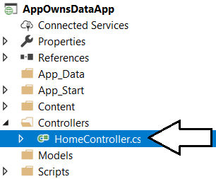

* 1. Inside **HomeController.cs**, you will find the starting point for the **HomeController** class with a single method named **Index**.

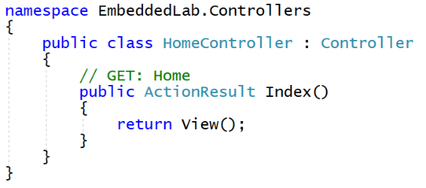

1. Add a view for the **Index** action method of the **Home** controller class.
   1. Inside **HomeController.cs**, right-click the **Index** method and select the **Add View…** command.

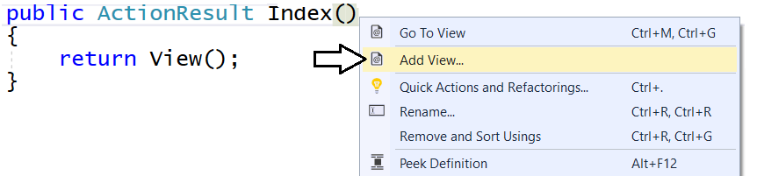

* 1. In the **Add View** dialog, accept all the default settings as shown in the following screenshot and click **Add**.

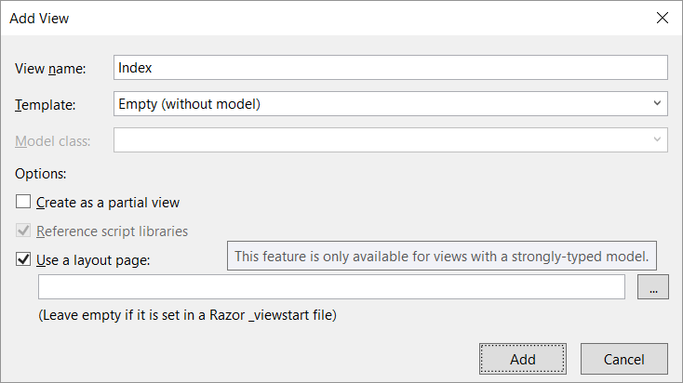

When you create a new view and leave the **Use a layout page** option selected, a new shared layout page named **_Layouts.cshtml** is automatically added to the project in the **Views/Shared** folder.

* 1. In Solution Explorer, you should be able to verify that your project contains two new files.
     1. Inside the **Views/Home** folder there is a new razor view file named **Index.cshtml**.
     2. Inside the **Views/Shared** folder there is a new shared layout page named **_Layouts.cshtml**.

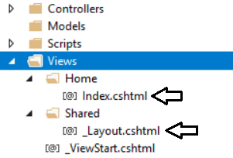

* 1. Examine the code that has been added to **Index.cshtml**.

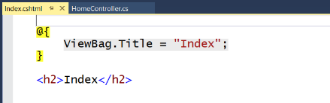

* 1. Delete all the code inside **Index.cshtml** and replace it with the following HTML code.

<div id="homePageContainer" class="container" >

<div class="jumbotron">

<h2>Welcome to the App-Owns-Data App</h2>

</div>

</div>

* 1. Save your changes and close **Index.cshtml**.

Over the next few steps, you will add the HTML code for a shared layouts page into **_Layout.cshtml** in a sequence of several different copy-and-paste operations. If you’d rather copy and paste the all the code for **_Layout.cshtml** at once, you can find the completed HTML code inside a file named **Layout.cshtml.txt** located in the **C:\Student\Modules\08_PowerBiEmbedding\Lab\Snippets** folder.

1. Modify the shared layouts page named **_Layouts.cshtml**.
   1. In Solution Explorer, expand the **Views** folder and then expand the **Shared** folder.
   2. Double-click on **_Layouts.cshtml** to open it in an editor window.
   3. Delete the entire contents of **_Layouts.cshtml** and replace it with the following HTML starter page.

<!DOCTYPE html>

<html>

<head>

</head>

<body>

</body>

</html>

* 1. Copy and paste the following HTML code to provide the **head** section

<head>

<meta charset="utf-8" />

<meta name="viewport" content="width=device-width, initial-scale=1.0">

<title>App-Owns-Data App</title>

<link href="~/Content/bootstrap.css" rel="stylesheet" />

<link href="~/Content/Site.css" rel="stylesheet" />

<script src="~/Scripts/jquery-3.4.1.js"></script>

<script src="~/Scripts/bootstrap.js"></script>

</head>

Make sure your script link to jQuery matches the version number of the jQuery library source file in the **Scripts** folder. The code listing above shows version **jquery-3.4.1.js** but your project might have a more recent version with a different version number.

* 1. Copy and paste the following HTML code to provide the **body** section of the page.

<body>

<!-- Add Banner with TopNav and Toolbar Here -->

<!-- Add Main Body Content Here -->

<!-- Add JavaScript Code to Resize Page Elements Here -->

</body>

Now you will copy and paste HTML markup code into each of the three sections in the HTML **body** element.

* 1. Copy and paste the following code into the body just below the ***Add Banner with TopNav and Toolbar Here*** comment.

<!-- Add Banner with TopNav and Toolbar Here -->

<div id="banner" class="container">

<nav id="topnav" class="navbar navbar-expand-sm navbar-dark bg-dark">

<ul class="navbar-nav">

<li class="nav-item active d-none d-md-block">

@Html.ActionLink("App-Owns-Data App", "Index", "Home",

routeValues: null, htmlAttributes: new { @class = "nav-link navbar-brand" })

</li>

<li class="nav-item">

@Html.ActionLink("Report", "Report", "Home",

routeValues: null, htmlAttributes: new { @class = "nav-link" })

</li>

<li class="nav-item">

@Html.ActionLink("Dashboard", "Dashboard", "Home",

routeValues: null, htmlAttributes: new { @class = "nav-link" })

</li>

<li class="nav-item">

@Html.ActionLink("Q&A", "Qna", "Home",

routeValues: null, htmlAttributes: new { @class = "nav-link" })

</li>

<li class="nav-item">

@Html.ActionLink("New Report", "NewReport", "Home",

routeValues: null, htmlAttributes: new { @class = "nav-link" })

</li>

</ul>

</nav>

@RenderSection("toolbar", required: false)

</div>

* 1. Copy and paste the following code into the body just below the **Add Main Body Content Here** comment

<!-- Add Main Body Content Here -->

<div id="content-box" class="container body-content">

@RenderBody()

</div>

* 1. Copy and paste the following code into the body just below the **Add Main Body Content Here** comment

<!-- Add JavaScript Code to Resize Page Elements -->

<script>

$(function () {

var heightBuffer = 12;

var newHeight = $(window).height() - ($("#banner").height() + heightBuffer);

$("#content-box").height(newHeight);

$("#embedContainer").height(newHeight);

$(window).resize(function () {

var newHeight = $(window).height() - ($("#banner").height() + heightBuffer);

$("#content-box").height(newHeight);

$("#embedContainer").height(newHeight);

});

});

</script>

* 1. Save your changes and close **_Layouts.cshtml**.

1. Modify the **Sites.css** file with a set of custom CSS styles.
   1. Using Windows Explorer, locate the snippet file named **Site.css.txt** in the **Students** at the following location.

C:\PowerBIEmbedding\Lab\Snippets\Site.css.txt

* 1. Double click on **Site.css.txt** to open it in Notepad.
  2. Select all the CSS code inside **Site.css.txt,** copy it to the Windows clipboard and return to Visual Studio.
  3. In Solution Explorer, expand the **Content** folder and then double-click on **Sites.css** open it in an editor window.

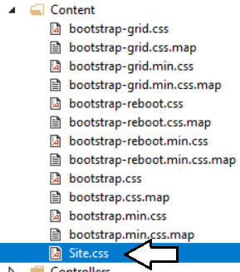

* 1. Delete all the existing content from **Sites.css** and paste in the content from the Windows clipboard.
  2. Save your changes and close **Sites.css**.

1. Add a new image named **background.jpg** to the project to provide a page background.
   1. Using Windows Explorer, locate the file named **background.jpg** in the **Students** folder at the following location.

C:\PowerBIEmbedding\Lab\StarterFiles\background.jpg

* 1. In Solution Explorer, create a new folder named **img** inside the **Contents** folder.
  2. Copy the file **background.jpg** into the **img** folder.

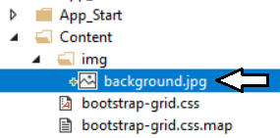

1. Add a **favicon.ico** file to the root folder of the **AppOwnsDataApp** project.
   1. Using Windows Explorer, locate the file named **favicon.icon** in the **Students** folder at the following location.

C:\PowerBIEmbedding\Lab\StarterFiles\favicon.ico

* 1. Copy the file named **favicon.ico** to the root folder of your project.

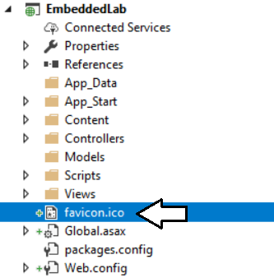

1. Test out the **AppOwnsDataApp** project using the Visual Studio debugger
   1. Press the **{F5}** key to start up the project in the Visual Studio debugger.
   2. When the project starts, the home page should load in the browser and match the following screenshot.

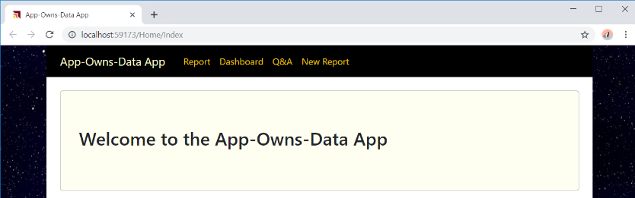

* 1. Close the browser, return to Visual Studio and stop the debugger.

Note that the navigation links on the top navigation menu are not working yet. Over the next few exercises, you will add MVC action methods and razor views to implement Power BI embedding behavior behind each of these navigation links.

## Exercise 8: Embedding Your First Power BI Report

In this exercise, you will create an action method and a razor view named **Report** which will embed a Power BI report.

1. Modify the project’s **web.config** file to add **appSetting** values for the required configuration data.
   1. Open the **web.config** file located at the root of the **AppOwnsDataApp** project.

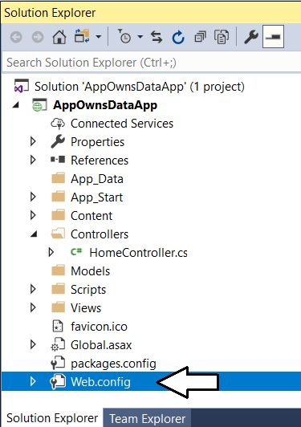

Make sure you open the **web.config** file located at the root of the project and not the **web.config** file inside the **Views** folder.

* 1. Locate the **<appSettings>** element at the top of **web.config**.
  2. Add a few blank lines just after the **<appSettings>** element opening tag.

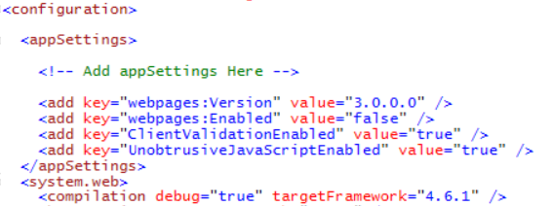

* 1. Copy and paste the following XML code into the **web.config** file underneath the **<appSettings>** opening tag.

<add key="application-id" value="" />

<add key="application-secret" value="" />

<add key="tenant-name" value="" />

<add key="app-workspace-id" value="" />

<add key="dataset-id" value="" />

<add key="report-id" value="" />

<add key="dashboard-id" value="" />

* 1. Copy the seven configuration values from **AppOwnsDataApp.txt** into the new **appSetting** values in **web.config.**
  2. You should be able to supply values for each of the seven **appSetting** values as shown in the following screenshot.

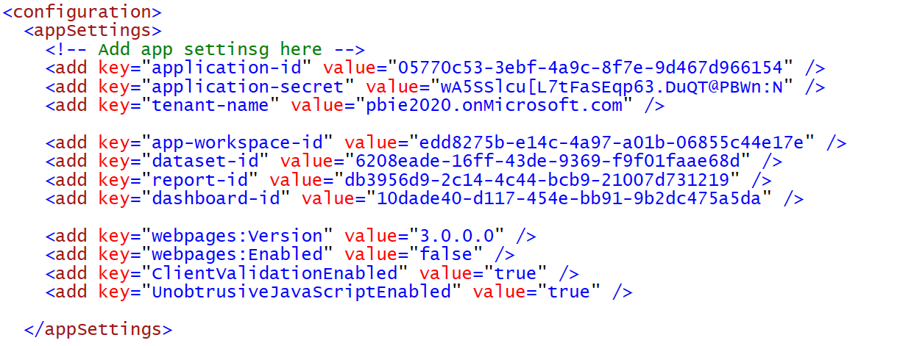

* 1. Save your changes and close **web.config**.

1. Create classes to provide MVC view models for Power BI embedding data.

Add a new C# source file named MvcViewModels.cs inside the Models folder.

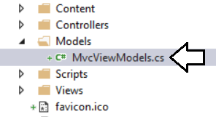

* 1. If there is any code inside **MvcViewModels.cs**, delete it and replace it with the following code.

using System;

namespace AppOwnsDataApp.Models {

// data required for embedding a report

public class ReportEmbeddingData {

public Guid reportId;

public string reportName;

public string embedUrl;

public string accessToken;

}

// data required for embedding a new report

public class NewReportEmbeddingData {

public Guid workspaceId;

public Guid datasetId;

public string embedUrl;

public string accessToken;

}

// data required for embedding a dashboard

public class DashboardEmbeddingData {

public Guid dashboardId;

public string dashboardName;

public string embedUrl;

public string accessToken;

}

// data required for embedding a dashboard

public class QnaEmbeddingData {

public Guid datasetId;

public string embedUrl;

public string accessToken;

}

}

* 1. Save your changes and close **MvcViewModels.cs**.

1. Create the **PbiEmbeddingManager** class.
   1. Add a new class named **PbiEmbeddingManager** inside the **Models** folder.
   2. The **Models** folder should now contain a C# source file named **PbiEmbeddingManager.cs**.

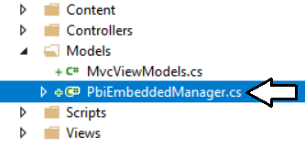

* 1. Delete any code inside **PbiEmbeddingManager.cs** and replace it with the following starter code.

using System;

using System.Configuration;

using System.Threading.Tasks;

using Microsoft.Identity.Client;

using Microsoft.PowerBI.Api;

using Microsoft.PowerBI.Api.Models;

using Microsoft.Rest;

namespace AppOwnsDataApp.Models {

public class PbiEmbeddingManager {

}

}

* 1. Modify the **PbiEmbeddingManager** class by adding the following set of static fields.

public class PbiEmbeddingManager {

private static readonly string ApplicationId = ConfigurationManager.AppSettings["application-id"];

private static readonly string ApplicationSecret = ConfigurationManager.AppSettings["application-secret"];

private static readonly string tenantName = ConfigurationManager.AppSettings["tenant-name"];

private static readonly Guid workspaceId = new Guid(ConfigurationManager.AppSettings["app-workspace-id"]);

private static readonly Guid datasetId = new Guid(ConfigurationManager.AppSettings["dataset-id"]);

private static readonly Guid reportId = new Guid(ConfigurationManager.AppSettings["report-id"]);

private static readonly Guid dashboardId = new Guid(ConfigurationManager.AppSettings["dashboard-id"]);

// endpoint for tenant-specific authority

private static readonly string tenantAuthority = "https://login.microsoftonline.com/" + tenantName;

// Power BI Service API Root URL

const string urlPowerBiRestApiRoot = "https://api.powerbi.com/";

}

In addition to the seven fields with configuration data, there are two other fields named **tenantAuthority** and **urlPowerBiRestApiRoot** which are used to authenticate with Azure AD and to determine the endpoint for the Power BI Service API.

* 1. At the bottom of **PbiEmbeddingManager** class, add a method named **GetAppOnlyAccessToken** using the following code.

static string GetAppOnlyAccessToken() {

var appConfidential = ConfidentialClientApplicationBuilder.Create(clientId)

.WithClientSecret(clientSecret)

.WithAuthority(tenantAuthority)

.Build();

string[] scopesDefault = new string[] { "https://analysis.windows.net/powerbi/api/.default" };

var authResult = appConfidential.AcquireTokenForClient(scopesDefault).ExecuteAsync().Result;

return authResult.AccessToken;

}

* 1. Underneath the **GetAppOnlyAccessToken** method, add a new method named **GetPowerBiClient** using the following code.

private static PowerBIClient GetPowerBiClient() {

var tokenCredentials = new TokenCredentials(GetAppOnlyAccessToken(), "Bearer");

return new PowerBIClient(new Uri(urlPowerBiRestApiRoot), tokenCredentials);

}

You have implemented the essential behavior in the **PbiEmbeddingManager** class to authenticate with Azure AD and to create new **PowerBIClient** objects which represents the top-level entry point into the Power BI Service API when using the Power BI .NET SDK. Now you are at a point where you can add methods to the **PbiEmbeddingManager** class to retrieve the data required for embedding.

1. Add the **GetReportEmbeddingData** method to the **PbiEmbeddingManager** class.
   1. At the bottom of the **PbiEmbeddingManager** class, add the **GetReportEmbeddingData** method using the following code.

public static async Task<ReportEmbeddingData> GetReportEmbeddingData() {

PowerBIClient pbiClient = GetPowerBiClient();

var report = await pbiClient.Reports.GetReportInGroupAsync(workspaceId, reportId);

var embedUrl = report.EmbedUrl;

var reportName = report.Name;

GenerateTokenRequest generateTokenRequestParameters = new GenerateTokenRequest(accessLevel: "edit");

string embedToken =

(await pbiClient.Reports.GenerateTokenInGroupAsync(workspaceId,

report.Id,

generateTokenRequestParameters)).Token;

return new ReportEmbeddingData {

reportId = reportId,

reportName = reportName,

embedUrl = embedUrl,

accessToken = embedToken

};

}

* 1. Save your changes to **PbiEmbeddedManger.cs**.

Now that you have added the **GetReportEmbeddingData** method, you will create a new action method in the **HomeController** class that calls this method.

1. Add the **Report** action method to the **HomeController** class.
   1. Inside the **Controllers** folder, open the C# source file named **HomeController.cs**.
   2. Update the set of **using** statements at the top of **HomeController.cs** using the following code.

using System;

using System.Collections.Generic;

using System.Linq;

using System.Threading.Tasks;

using System.Web;

using System.Web.Mvc;

using AppOwnsDataApp.Models;

* 1. Underneath the **Index** method, add a new asynchronous action method named **Report** using the following code.

public class HomeController : Controller {

public ActionResult Index() {

return View();

}

public async Task<ActionResult> Report() {

ReportEmbeddingData embeddingData = await PbiEmbeddingManager.GetReportEmbeddingData();

return View(embeddingData);

}

}

* 1. Right-click on the **Report** method and select the **Add View…** command from the context menu.
  2. In the **Add View** dialog, accept all the default settings and click the **Add** button.

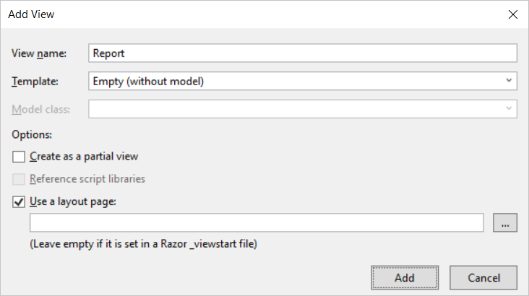

* 1. You should be able to verify that a new razor view file named **Report.cshtml** has been created in the **Views/Home** folder.
  2. Delete all existing content from **Report.cshtml** and replace it with the following code.

@model AppOwnsDataApp.Models.ReportEmbeddingData

<div id="embedContainer" />

<script src="~/Scripts/powerbi.js"></script>

<script>

// data required for embedding Power BI report

var embedReportId = "@Model.reportId";

var embedUrl = "@Model.embedUrl";

var accessToken = "@Model.accessToken";

// Get models object to access enums for embed configuration

var models = window['powerbi-client'].models;

var config = {

type: 'report',

id: embedReportId,

embedUrl: embedUrl,

accessToken: accessToken,

permissions: models.Permissions.All,

tokenType: models.TokenType.Embed,

viewMode: models.ViewMode.View,

settings: {

filterPaneEnabled: false,

navContentPaneEnabled: true,

}

};

// Get a reference to HTML element that will be embed container

var reportContainer = document.getElementById('embedContainer');

// Embed the report and display it within the div container.

var report = powerbi.embed(reportContainer, config);

</script>

* 1. Save your changes and close **Report.cshtml**.

1. Test out the application by running it in the Visual Studio debugger.
   1. Press the **{F5}** key in Visual Studio to begin a new debugging session.
   2. Click the **Report** link in the top navigation menu.

If the editor window with a razor view such as **Report.cshtml** is the active window when you press the **{F5}**, the Visual Studio debugger will automatically take you to this view at the start of your debugging session.

* 1. You should now see the **Wingtip Sales Analysis** report has been embedded on the page for the **Report** view.

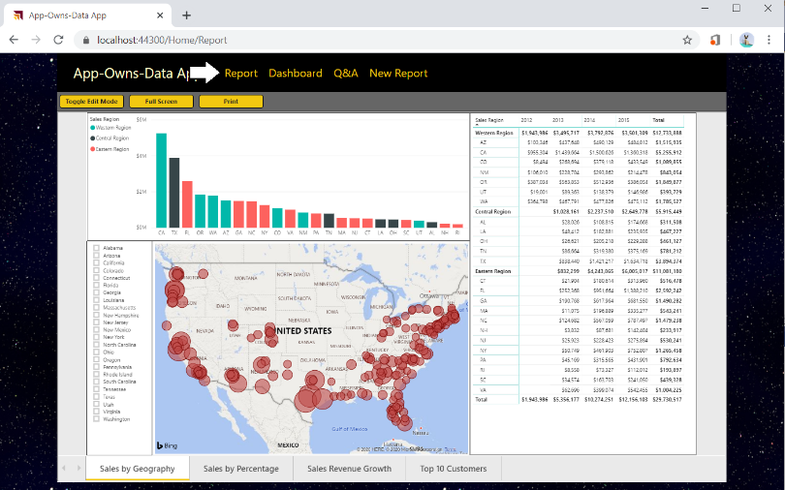

Try resizing the browser window. You will see that your application responds by dynamically changing the size of the HTML element with the ID of **embedContainer** and the embedded report responds automatically by changing its size to fit the new dimensions.

* 1. Close the browser window, return to Visual Studio and stop the current debugging session.

## Exercise 9: Adding a Toolbar for Embedded Reports

In this exercise, you continue to work on **Report.cshtml** by adding a new toolbar with three command buttons. You will also add JavaScript code behind these command buttons to invoke actions on the embedded report.

1. Add the HTML layout code for a toolbar into **Report.cshtml**.
   1. Open **Report.cshtml** if it is not already open.
   2. Copy and paste the following HTML code into **Report.cshtml** just below the **@model** directive at the top.

@section toolbar {

<div id="toolbar" class="btn-toolbar bg-dark" role="toolbar" >

<button type="button" id="toggleEdit" class="btn btn-sm" >Toggle Edit Mode</button>

<button type="button" id="fullScreen" class="btn btn-sm" >Full Screen</button>

<button type="button" id="print" class="btn btn-sm" >Print</button>

</div>

}

* 1. The top of **Report.cshtml** should match the following screenshot.

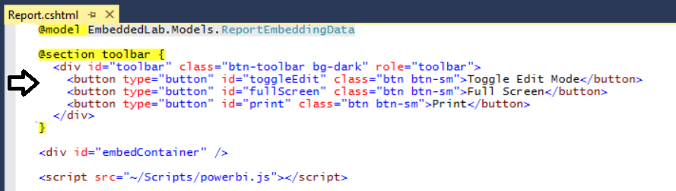

* 1. Inside **Report.cshtml**, move down inside **<script>** block and add a few new lines after the line which calls **powerbi.embed**.
  2. Copy and paste the following JavaScript code at the bottom of the **<script>** block just before the closing **</script>** tag.

var viewMode = "view";

$("#toggleEdit").click(function () {

// toggle between view and edit mode

viewMode = (viewMode == "view") ? "edit" : "view";

report.switchMode(viewMode);

// show filter pane when entering edit mode

var showFilterPane = (viewMode == "edit");

report.updateSettings({

"filterPaneEnabled": showFilterPane

});

});

$("#fullScreen").click(function () {

report.fullscreen();

});

$("#print").click(function () {

report.print();

});

* 1. Save your changes to **Report.cshtml**.

1. Test out the application by running it in the Visual Studio debugger.
   1. Press the **{F5}** key in Visual Studio to begin a new debugging session.
   2. Click the **Report** link in the top navigation menu.
   3. You should now see three toolbar buttons with the captions **Toggle Edit Mode**, **Full Screen** and **Print**.

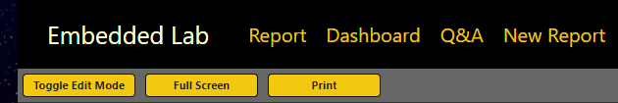

* 1. Click the **Toggle Edit Mode** button several times. The report should toggle back and forth between edit and reader mode.

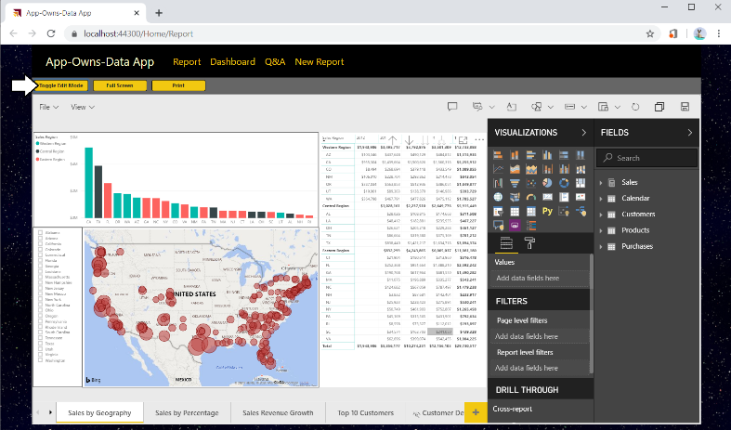

* 1. Experiment by clicking the **Full Screen** button.
  2. Experiment by clicking the **Print button**.
  3. Close the browser window and return to Visual Studio and stop the current debugging session.

## Exercise 10: Embedding a Dashboard

In this exercise you will embed a dashboard. As you will see, it’s not very different from the steps you have already implemented to embed a report.

1. Add a new method to the **PbiEmbeddingManger** class named **GetDashboardEmbeddingData**.
   1. Open **PbiEmbeddingManager.cs** in an editor window if it’s not already open.
   2. Navigate to the bottom of the class definition just beneath the **GetReportEmbeddingData** method
   3. Paste in the definition for a new method named **GetDashboardEmbeddingData** using the following code.

public static async Task<DashboardEmbeddingData> GetDashboardEmbeddingData() {

PowerBIClient pbiClient = GetPowerBiClient();

var dashboard = await pbiClient.Dashboards.GetDashboardInGroupAsync(workspaceId, dashboardId);

var embedUrl = dashboard.EmbedUrl;

var dashboardDisplayName = dashboard.DisplayName;

GenerateTokenRequest generateTokenRequestParameters = new GenerateTokenRequest(accessLevel: "view");

string embedToken =

(await pbiClient.Dashboards.GenerateTokenInGroupAsync(workspaceId,

dashboardId,

generateTokenRequestParameters)).Token;

return new DashboardEmbeddingData {

dashboardId = dashboardId,

dashboardName = dashboardDisplayName,

embedUrl = embedUrl,

accessToken = embedToken

};

}

* 1. Save your changes to **PbiEmbeddingManager.cs**.

1. Add a new action method to the **HomeController** class named **Dashboard**.
   1. Open **HomeController.cs** in an editor window if it’s not already open.
   2. Add a new action method named **Dashboard** just beneath the **Report** method using the following code.

public async Task<ActionResult> Dashboard() {

DashboardEmbeddingData embeddingData = await PbiEmbeddingManager.GetDashboardEmbeddingData();

return View(embeddingData);

}

1. Create a razor view for the **Dashboard** action method.
   1. Right-click on the **Dashboard** action method and select the **Add View…** command from the context menu.
   2. In the **Add View** dialog, accept all the default settings and click the **Add** button.

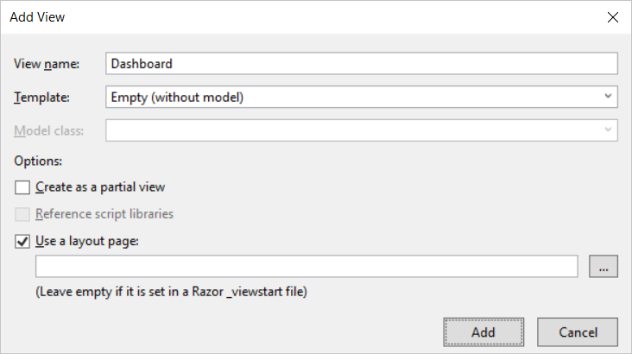

* 1. You should see that a new razor view file named **Dashboard.cshtml** has been created in the **Views/Home** folder.
  2. Delete any existing code inside **Dashboard.cshtml** and replace it with the following HTML code.

@model AppOwnsDataApp.Models.DashboardEmbeddingData

<div id="embedContainer" />

<script src="~/Scripts/powerbi.js"></script>

<script>

// data required for embedding Power BI report

var embedDashboardId = "@Model.dashboardId";

var embedUrl = "@Model.embedUrl";

var accessToken = "@Model.accessToken";

// Get models object to access enums for embed configuration

var models = window['powerbi-client'].models;

var config = {

type: 'dashboard',

id: embedDashboardId,

embedUrl: embedUrl,

accessToken: accessToken,

tokenType: models.TokenType.Embed,

pageView: "fitToWidth"

};

// Get a reference to the embedded report HTML element

var embedContainer = document.getElementById('embedContainer');

// Embed the report and display it within the div container.

var dashboard = powerbi.embed(embedContainer, config);

</script>

* 1. Save your changes to **Dashboard.cshtml**.

1. Test out the application by running it in the Visual Studio debugger.
   1. Press the **{F5}** key in Visual Studio to begin a new debugging session.
   2. Click the **Dashboard** link in the top navigation menu and you should see the dashboard embedded in the web page.

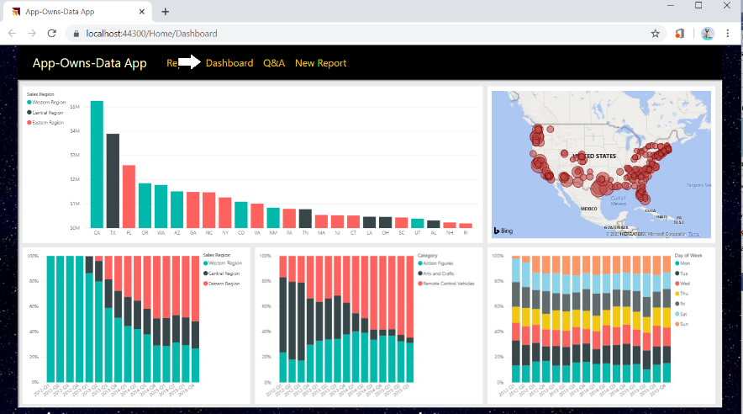

* 1. Try changing the size of the browser window and see how the application responds by adjusting the size of the dashboard.
  2. Close the browser window and return to Visual Studio and stop the current debugging session.

## Exercise 11: Embedding the Power BI Q&A Experience

In this exercise you will embed the Power BI Q&A experience. To accomplish this, you will be required to provide the dataset ID associated with the dataset on which you want to execute natural language queries.

1. Add a new method to the **PbiEmbeddingManger** class named **GetQnaEmbeddingData**.
   1. Open **PbiEmbeddingManager.cs** in an editor if it’s not already open.
   2. Navigate to the bottom of the class definition just beneath the **GetDashboardEmbeddingData** method
   3. Add a new method named **GetQnaEmbeddingData** by copying and pasting the following code.

public async static Task<QnaEmbeddingData> GetQnaEmbeddingData() {

PowerBIClient pbiClient = GetPowerBiClient();

var dataset = await pbiClient.Datasets.GetDatasetInGroupAsync(workspaceId, datasetId.ToString());

string embedUrl = "https://app.powerbi.com/qnaEmbed?groupId=" + workspaceId;

GenerateTokenRequest generateTokenRequestParameters = new GenerateTokenRequest(accessLevel: "view");

string embedToken =

(await pbiClient.Datasets.GenerateTokenInGroupAsync(workspaceId,

dataset.Id,

generateTokenRequestParameters)).Token;

return new QnaEmbeddingData {

datasetId = datasetId,

embedUrl = embedUrl,

accessToken = embedToken

};

}

* 1. Save your changes to Open **PbiEmbeddingManager.cs**.

1. Add a new action method to the **HomeController** class named **Qna**.
   1. Open **HomeController.cs** in an editor window if it’s not already open.
   2. Add a new action method named **Qna** just beneath the **Dashboard** method using the following code.

public async Task<ActionResult> Qna() {

QnaEmbeddingData embeddingData = await PbiEmbeddingManager .GetQnaEmbeddingData();

return View(embeddingData);

}

1. Create a razor view for the **Qna** action method.
   1. Right-click on the **Qna** action method and select the **Add View…** command from the context menu.
   2. In the **Add View** dialog, accept all the default settings and click the **Add** button.

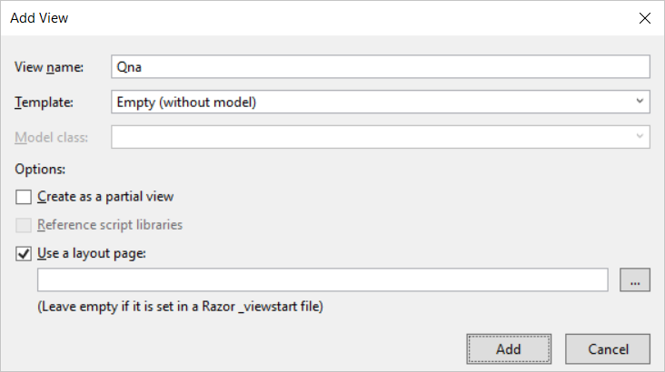

* 1. You should see that a new razor view file named **Qna.cshtml** has been created in the **Views/Home** folder.
  2. Delete any existing code inside **Qna.cshtml** and replace it with the following HTML code.

@model AppOwnsDataApp.Models.QnaEmbeddingData

<div id="embedContainer" />

<script src="~/Scripts/powerbi.js"></script>

<script>

// Get data required for embedding

var datasetId = "@Model.datasetId";

var embedUrl = "@Model.embedUrl";

var accessToken = "@Model.accessToken";

// Get models object to access enums for embed configuration

var models = window['powerbi-client'].models;

var config = {

type: 'qna',

tokenType: models.TokenType.Embed,

accessToken: accessToken,

embedUrl: embedUrl,

datasetIds: [datasetId],

viewMode: models.QnaMode.Interactive,

question: "What is sales revenue by quarter and sales region as stacked area chart"

};

// Get a reference to the embedded report HTML element

var embedContainer = document.getElementById('embedContainer');

// Embed the report and display it within the div container.

var embeddedObject = powerbi.embed(embedContainer, config);

</script>

* 1. Save your changes to **Qna.cshtml**.

1. Test out the application by running it in the Visual Studio debugger.
   1. Press the **{F5}** key in Visual Studio to begin a new debugging session.
   2. Click the **Q&A** link in the top navigation menu and you should see the Q&A experience embedded in the web page.

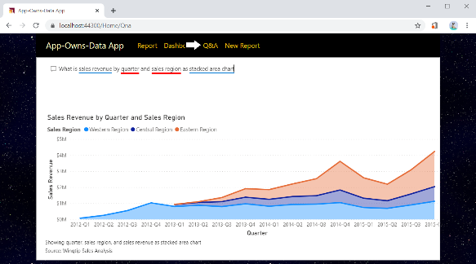

* 1. Experiment by typing questions in English and seeing how the Q&A experience responds with data and visualizations.
  2. Close the browser window, return to Visual Studio and stop the current debugging session.

## Exercise 12: Embedding a New Report

In this exercise you will implement the behavior to embed a new report based on a specific dataset. This exercise will be a bit more complicated than the previous exercises because you must implement a client-side event handler to handle the report “Save As” event in which you will redirect the browser to a new action method named **Reports** passing the new report ID in a query string parameter.

1. Add a new method to the **PbiEmbeddingManger** class named **GetNewReportEmbeddingData**.
   1. Open **PbiEmbeddingManager.cs** in an editor window if it is not already open.
   2. Navigate to the bottom of the class definition just beneath the **GetQnaEmbeddingData** method.
   3. Add a new method named **GetNewReportEmbeddingData** by copying and pasting the following code.

public static async Task<NewReportEmbeddingData> GetNewReportEmbeddingData() {

string embedUrl = "https://app.powerbi.com/reportEmbed?groupId=" + workspaceId;

PowerBIClient pbiClient = GetPowerBiClient();

GenerateTokenRequest generateTokenRequestParameters =

new GenerateTokenRequest(accessLevel: "create", datasetId: datasetId.ToString());

string embedToken =

(await pbiClient.Reports.GenerateTokenForCreateInGroupAsync(workspaceId,

generateTokenRequestParameters)).Token;

return new NewReportEmbeddingData {

workspaceId = workspaceId,

datasetId = datasetId,

embedUrl = embedUrl,

accessToken = embedToken

};

}

Notice that you are required to pass a dataset ID when generating an embed token which will be used to embed a new report.

1. Add a new action method to the **HomeController** class named **NewReport**.
   1. Open **HomeController.cs** in an editor window if it’s not already open.
   2. Add a new action method named **NewReport** just beneath the **Qna** method using the following code.

public async Task<ActionResult> NewReport() {

NewReportEmbeddingData embeddingData = await PbiEmbeddingManager .GetNewReportEmbeddingData();

return View(embeddingData);

}

1. Create a razor view for the **NewReport** action method.
   1. Right-click on the **NewReport** action method and select the **Add View…** command from the context menu.
   2. In the **Add View** dialog, accept all the default settings and click the **Add** button.

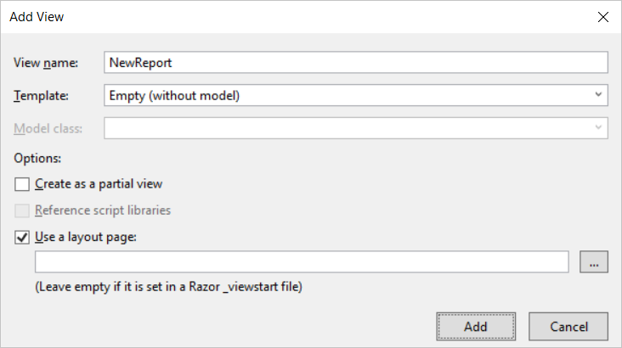

* 1. You should see that a new razor view file named **NewReport.cshtml** has been created in the **Views/Home** folder.
  2. Delete any existing code inside **NewReport.cshtml** and replace it with the following HTML code.

@model AppOwnsDataApp.Models.NewReportEmbeddingData

<div id="embedContainer" />

<script src="~/Scripts/powerbi.js"></script>

<script>

// Get data required for embedding

var embedWorkspaceId = "@Model.workspaceId";

var embedDatasetId = "@Model.datasetId";

var embedUrl = "@Model.embedUrl";

var accessToken = "@Model.accessToken";

// Get models object to access enums for embed configuration

var models = window['powerbi-client'].models;

var config = {

datasetId: embedDatasetId,

embedUrl: embedUrl,

accessToken: accessToken,

tokenType: models.TokenType.Embed,

};

// Get a reference to the embedded report HTML element

var embedContainer = document.getElementById('embedContainer');

// Embed the report and display it within the div container.

var report = powerbi.createReport(embedContainer, config);

// add event handler to load existing report afer saving new report

report.on("saved", function (event) {

console.log("saved");

console.log(event.detail);

window.location.href = "/Home/Reports/?reportId=" + event.detail.reportObjectId;

});

</script>

* 1. Save your changes to **NewReport.cshtml**.

You should observe how the code in this script block registers a callback function by calling the **report.on(“Saved”)** method. You should also observe that this event handle is written to redirect the browser to the **Reports** action of the **Home** controller along with a query string parameter named **reportId** which will be used to pass the identifying GUID of the newly created report. Over the next few steps you will add the **Reports** action method to the **Home** controller class to load an existing report that has just been created.

1. Add a new method to the **PbiEmbeddingManger** class named **GetEmbeddingDataForReport**.
   1. In **PbiEmbeddingManager.cs**, add the **GetEmbeddingDataForReport** method by copying and pasting the following code.

public static async Task<ReportEmbeddingData> GetEmbeddingDataForReport(string currentReportId) {

// convert string-based report ID to GUID

Guid reportId = new Guid(currentReportId);

PowerBIClient pbiClient = GetPowerBiClient();

var report = await pbiClient.Reports.GetReportInGroupAsync(workspaceId, reportId);

var embedUrl = report.EmbedUrl;

var reportName = report.Name;

GenerateTokenRequest generateTokenRequestParameters = new GenerateTokenRequest(accessLevel: "edit");

string embedToken =

(await pbiClient.Reports.GenerateTokenInGroupAsync(workspaceId,

reportId,

generateTokenRequestParameters)).Token;

return new ReportEmbeddingData {

reportId = reportId,

reportName = reportName,

embedUrl = embedUrl,

accessToken = embedToken

};

}

1. Add a new action method to the **HomeController** class named **Reports**.
   1. Open **HomeController.cs** in an editor window if it’s not already open.
   2. Add a new action method named **Reports** just beneath the **NewReports** method using the following code.

public async Task<ActionResult> Reports(string reportId) {

ReportEmbeddingData embeddingData =

await PbiEmbeddingManager.GetEmbeddingDataForReport(reportId);

return View(embeddingData);

}

1. Create a razor view for the **Reports** action method.
   1. Right-click on the R**eports** action method and select the **Add View…** command from the context menu.
   2. In the **Add View** dialog, accept all the default settings and click the **Add** button.

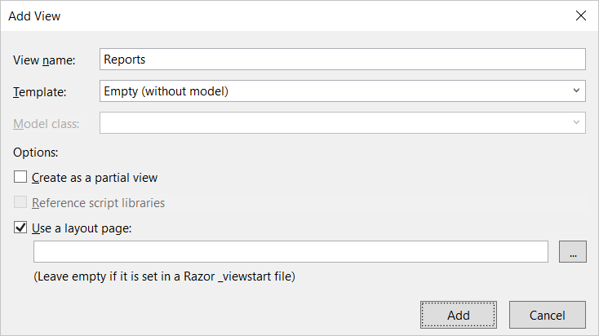

* 1. You should see that a new razor view file named **Reports.cshtml** has been created in the **Views/Home** folder.

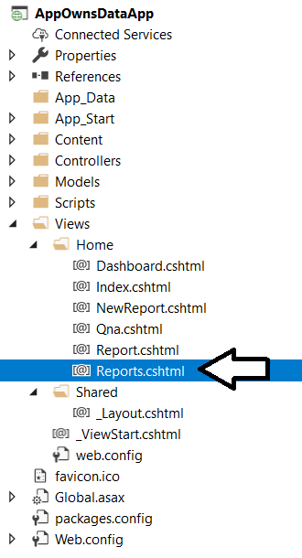

* 1. Delete any existing code inside **Reports.cshtml** and replace it with the following HTML code.

@model AppOwnsDataApp.Models.ReportEmbeddingData

@section toolbar {

<div id="toolbar" class="btn-toolbar bg-dark" role="toolbar">

<button type="button" id="toggleEdit" class="btn btn-sm">Toggle Edit Mode</button>

<button type="button" id="fullScreen" class="btn btn-sm">Full Screen</button>

<button type="button" id="print" class="btn btn-sm">Print</button>

</div>

}

<div id="embedContainer" />

<script src="~/Scripts/powerbi.js"></script>

<script>

// Data required for embedding Power BI report

var embedReportId = "@Model.reportId";

var embedUrl = "@Model.embedUrl";

var accessToken = "@Model.accessToken";

// Get models object to access enums for embed configuration

var models = window['powerbi-client'].models;

var config = {

type: 'report',

id: embedReportId,

embedUrl: embedUrl,

accessToken: accessToken,

tokenType: models.TokenType.Embed,

permissions: models.Permissions.All,

viewMode: models.ViewMode.Edit,

settings: {

filterPaneEnabled: false,

navContentPaneEnabled: true,

}

};

// Get a reference to HTML element that will be embed container

var reportContainer = document.getElementById('embedContainer');

// Embed the report and display it within the div container.

var report = powerbi.embed(reportContainer, config);

var viewMode = "edit";

$("#toggleEdit").click(function () {

// toggle between view and edit mode

viewMode = (viewMode == "view") ? "edit" : "view";

report.switchMode(viewMode);

// show filter pane when entering edit mode

var showFilterPane = (viewMode == "edit");

report.updateSettings({

"filterPaneEnabled": showFilterPane

});

});

$("#fullScreen").click(function () {

report.fullscreen();

});

$("#print").click(function () {

report.print();

});

</script>

1. Test out the application by running it in the Visual Studio debugger.
   1. Press the **{F5}** key in Visual Studio to begin a new debugging session.
   2. Click the **New Report** link in the top navigation menu and you should see an new empty in design mode.
   3. Add one or two visuals to the new report.
   4. Save the new report by dropping down the **File** menu and selecting the **Save as** command.

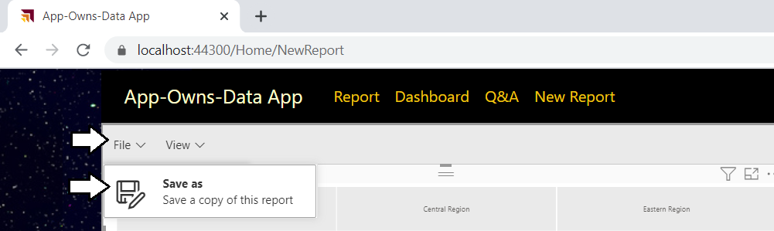

* 1. In the **Save your report** dialog, give the new report a name such as **My New Report** and click the **Save** button.

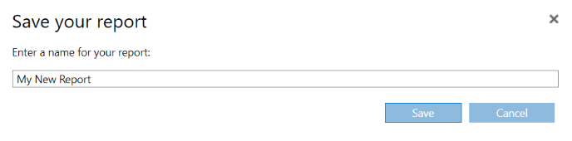

* 1. After the report has been saved, the browser should redirect to the **Home/Reports** action method and your application should be able to load in the newly created report using the GUID for its report ID.

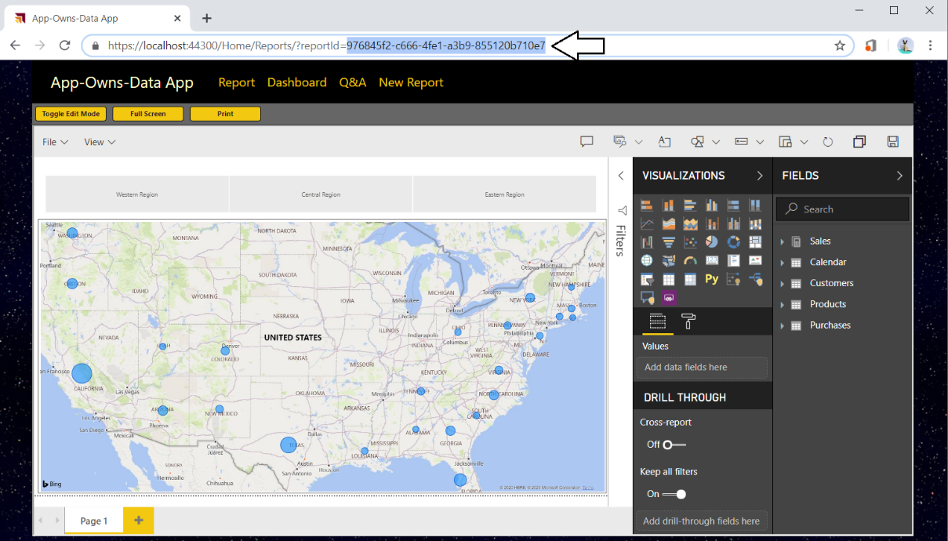

* 1. When you are done with your testing, close the browser, return to Visual Studio and stop the current debugging session.

Congratulations. You have made it to the end of this lab.